LOVE LIKE JESUS | THE LORD’S TABLE
WAVE CHURCH SD | APRIL 5, 2020

Luke 7:34 (ESV) The Son of Man has come eating and drinking, and you say, ‘Look at him! A glutton and a drunkard, a friend of tax collectors and sinners!’

JESUS INVITES US TO HIS TABLE TO REMEMBER

Luke 22:14-20 (ESV) ¹⁴ And when the hour came, he reclined at table, and the apostles with him. ¹⁵ And he said to them, “I have earnestly desired to eat this Passover with you before I suffer. ¹⁶ For I tell you I will not eat it until it is fulfilled in the kingdom of God.” ¹⁷ And he took a cup, and when he had given thanks he said, “Take this, and divide it among yourselves. ¹⁸ For I tell you that from now on I will not drink of the fruit of the vine until the kingdom of God comes.” ¹⁹ And he took bread, and when he had given thanks, he broke it and gave it to them, saying, “This is my body, which is given for you. Do this in remembrance of me.” ²⁰ And likewise the cup after they had eaten, saying, “This cup that is poured out for you is the new covenant in my blood.

DO THIS IN REMEMBRANCE OF ME…

WHY COMMUNION?

- WE ARE A FORGETFUL PEOPLE | WE FORGET OUR NEED FOR GOD AND FOR ONE ANOTHER!

- WE ARE EASILY DISTRACTED

- DARK DAYS ARE COMING

WHAT ARE WE TO REMEMBER WHEN WE TAKE COMMUNION?

REMEMBER OUR SALVATION | LUKE 22:14-15

REMEMBER WHAT WAS SACRIFICED | MARK 14:22-24

REMEMBER WE ARE SINNERS SAVED BY GRACE | MARK 14:26-31

- JESUS ONLY WELCOMES SINNERS AROUND HIS TABLE

REMEMBER WE ARE SERVANTS | LUKE 22:25-30

REMEMBER ANOTHER SUPPER IS COMING | LUKE 22:16-18

“If you read history you will find that the Christians who did most for the present world were precisely those who thought most of the next. It is since Christians have largely ceased to think of the other world that they have become so ineffective in this one.” – C.S. Lewis

1 Corinthians 11:23-26 (ESV) ²³ For I received from the Lord what I also delivered to you, that the Lord Jesus on the night when he was betrayed took bread, ²⁴ and when he had given thanks, he broke it, and said, “This is my body, which is for you. Do this in remembrance of me.” ²⁵ In the same way also he took the cup, after supper, saying, “This cup is the new covenant in my blood. Do this, as often as you drink it, in remembrance of me.” ²⁶ For as often as you eat this bread and drink the cup, you proclaim the Lord’s death until he comes.

CONNECT.
.
WAVE CHURCH ONLINE | Sundays
During this unprecedented time, it is more important than ever that we remain connected even when we are separated. Join us for Wave Church SD ONLINE Sunday morning at 10 a.m. Visit our Website to access the video link, worship videos from Tiffany and Matt, and a family church reading and activity.
wavechurchsd.com/churchonline
WAVE WEEKLY NEWSLETTER
Want to keep up with all that is going on at Wave? Simply fill out your communication card and write ‘Newsletter’ to get a weekly email update
from Wave!
GROW.
.
SERMON PODCASTS | wavechurchsd.com/sermons/
Want to hear a sermon again, or share it with a friend or family member? Download our sermon podcasts at wavechurchsd.com/sermons/. Access it
on our Website or on the Wave Church SD YouTube channel.
SERVE.
.
HOW CAN YOU HELP YOU? | (858) 465-4144
Wave has developed a texting app for you to text us your prayer requests and physical needs over the coming weeks. With many people self-quarantining, there will certainly be needs and shortages of supplies. This is an opportunity to BE THE CHURCH. Please text your need to (858) 465-4144 and we will seek to share our resources with one another and our neighbors.

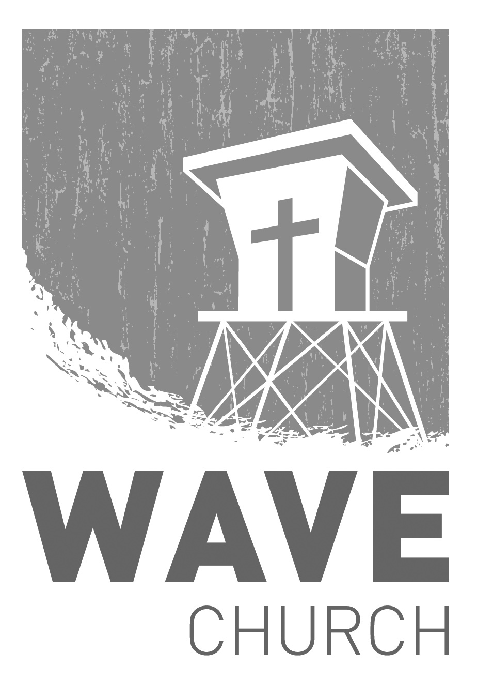
Wave Church

Welcome to

Connect | Grow | Serve

Sundays at 10 a.m.
Willow Grove Elementary
14727 Via Azul
San Diego, CA | 92127
858-859-2831
Wavechurchsd.com

