WAVE CHURCH SD | SERVE SUNDAY
AUGUST 4, 2019

Luke 4:40 (NLT)

⁴⁰ As the sun went down that evening, people throughout the village brought sick family members to Jesus. No matter what their diseases were, the touch of his hand healed every one.

Matthew 14:13-14 (NLT)

¹³ As soon as Jesus heard the news, he left in a boat to a remote
area to be alone. But the crowds heard where he was headed and followed on foot from many towns. ¹⁴ Jesus saw the huge crowd as he stepped from the boat, and he had compassion on them and healed their sick.

Matthew 8:16-17 (NLT)

¹⁶ That evening many demon-possessed people were brought to Jesus. He cast out the evil spirits with a simple command, and he healed all the sick. ¹⁷ This fulfilled the word of the Lord through
the prophet Isaiah, who said, “He took our sicknesses and removed our diseases.”

Matthew 9:35-38 (NLT)

³⁵ Jesus traveled through all the towns and villages of that area, teaching in the synagogues and announcing the Good News about the Kingdom. And he healed every kind of disease and illness. ³⁶ When he saw the crowds, he had compassion on them because they were confused and helpless, like sheep without a shepherd. ³⁷ He said to his disciples, “The harvest is great, but the workers are few. ³⁸ So pray to the Lord who is in charge of the harvest; ask him to send more workers into his fields.”

WHY?

I BELIEVE I WAS PUT ON THIS EARTH TO MAKE A DIFFERENCE.

I BELIEVE THE BEST WAY TO MAKE A DIFFERENCE IS THROUGH LOVE.

I BELIEVE THE GREATEST EXAMPLE OF A LIFE OF LOVE IS JESUS.

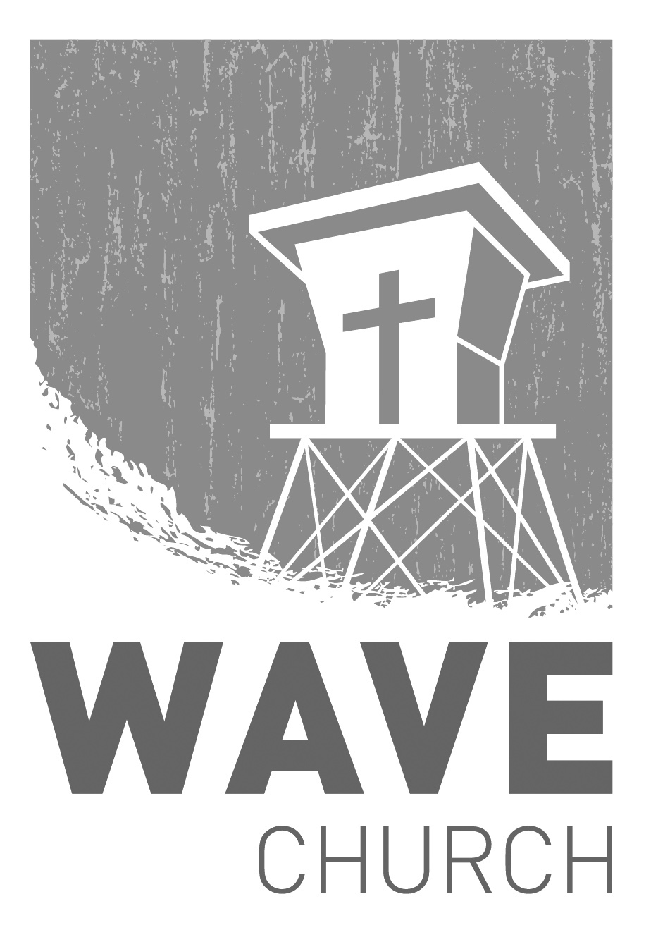
CONNECT.
Wave Church

Welcome to

Connect | Grow | Serve

Sundays at 10 a.m.
Willow Grove Elementary
14727 Via Azul
San Diego, CA | 92127
858-859-2831
Wavechurchsd.com
.
WAVE WEEKLY NEWSLETTER
Want to keep up with all that is going on at Wave? Simply fill out your communication card and write ‘Newsletter’ to get a weekly email update
from Wave!
GROW.
.
SERMON PODCASTS | wavechurchsd.com/sermons/
Summer is in full swing – although no one has told the weather! Many of us
will be traveling and can’t make it to church, but you can still keep up with our sermons online! Want to hear a section again, or send it to a friend? Download our sermon podcasts at http://wavechurchsd.com/sermons/
SERVE.
.
WAVE FAMILY CAMP | Aug. 8-10, 2019
Our first Wave Family Camp is finally here! Making quality connections is what missions are all about, so please bring your whole family! If you would like to go, but haven’t signed up yet, please register through the Newsletter TODAY! We’d love to have you join us!
* If you aren’t able to go, please be in prayer for the 31 people going to Door of Faith this weekend that everyone would have a safe journey, that friendships would be forged, and for hearts to be opened to the wonderful things God has in store for everyone!
WE NEED YOUR HELP | Serve Teams
We have a few service teams who are looking for more volunteers. Are you part of a serve team yet? Or would you like to try something new? Serving is a great way to make new connections, while making a difference in our church body. Please fill out a connection card with your name and the area you would be willing to serve, and a team leader will be in touch with you!

- Hospitality: Greeters
- Audio/Visual: Slides
- Kids Ministry: Classroom volunteers

