WAVE CHURCH SD | SIMPLE FAITH
Colossians 2:6-23 | Aug. 18, 2019

KEEP FAITH SIMPLE

SIMPLICITY:
“The quality or condition of being easy to understand or do.”

Colossians 2:6-7 (NIV) ⁶ And now, just as you accepted Christ Jesus as your Lord, you must continue to follow him. ⁷ Let your roots grow down into him, and let your lives be built on him. Then your faith will grow strong in the truth you were taught, and you will overflow with thankfulness.

SIMPLE FAITH = A LIFESTYLE OF SAYING YES TO JESUS

A SIMPLE FAITH WILL MAKE A COMPLICATED WORLD
THINK YOU ARE FOOLISH.

1 Corinthians 1:26-29 (NLT) ²⁶ Remember, dear brothers and sisters, that few of you were wise in the world’s eyes or powerful or wealthy when God called you. ²⁷ Instead, God chose things the world considers foolish in order to shame those who think they are wise. And he chose things that are powerless to shame those who are powerful. ²⁸ God chose things despised by the world, things counted as nothing at all, and used them to bring to nothing what the world considers important. ²⁹ As a result, no one can ever boast in the presence of God.

Colossians 2:16 (NIV) ¹⁶ Therefore do not let anyone judge you by what you eat or drink, or with regard to a religious festival, a New Moon celebration or a Sabbath day.

YOU WILL BE JUDGED BY WHAT YOU WORSHIP.

LIVE YOUR LIFE IN SUCH A WAY THAT NO ONE CAN EVER QUESTION YOUR LOVE AND PRIORITY FOR JESUS.

Colossians 2:17-19 (NIV) ¹⁷ These are a shadow of the things that were to come; the reality, however, is found in Christ. ¹⁸ Do not let anyone who delights in false humility and the worship of angels disqualify you. Such a person also goes into great detail about what they have seen; they are puffed up with idle notions by their unspiritual mind. ¹⁹ They have lost connection with the head, from whom the whole body, supported and held together by its ligaments and sinews, grows as God causes it to grow.

TWO WARNINGS

- BE ON GUARD FOR RELIGIOUS APOSTATES

- BE ON GUARD NOT TO ALLOW YOUR AGENDAS TO LEAD YOU

Matthew 23:13-15 (NLT) ¹³ “What sorrow awaits you teachers of religious law and you Pharisees. Hypocrites! For you shut the door of the Kingdom of Heaven in people’s faces. You won’t go in yourselves, and you don’t let others enter either. ¹⁵ “What sorrow awaits you teachers of religious law and you Pharisees. Hypocrites! For you cross land and sea to make one convert, and then you turn that person into twice the child of hell you yourselves are!

Colossians 2:20-23 (NIV) ²⁰ Since you died with Christ to the elemental spiritual forces of this world, why, as though you still belonged to the world, do you submit to its rules: ²¹ “Do not handle! Do not taste! Do not touch!”? ²² These rules, which have to do with things that are all destined to perish with use, are based on merely human commands and teachings. ²³ Such regulations indeed have an appearance of wisdom, with their self-imposed worship, their false humility and their harsh treatment of the body, but they lack any value in restraining sensual indulgence.

SELF-MADE RELIGION

- RELIGION OF LEGALISM | RULES + JESUS

- RELIGION OF WORKS | GOOD DEEDS + JESUS

- RELIGION OF SUCCESS | HEALTH, WEALTH, PROSPERITY + JESUS

- RELIGION OF EMOTIONALISM | EMOTIONS + JESUS

- RELIGION OF INTELLECTUALISM | DEEP THINKING + JESUS

- RELIGION OF ASCETISM | SELF DENIAL + JESUS

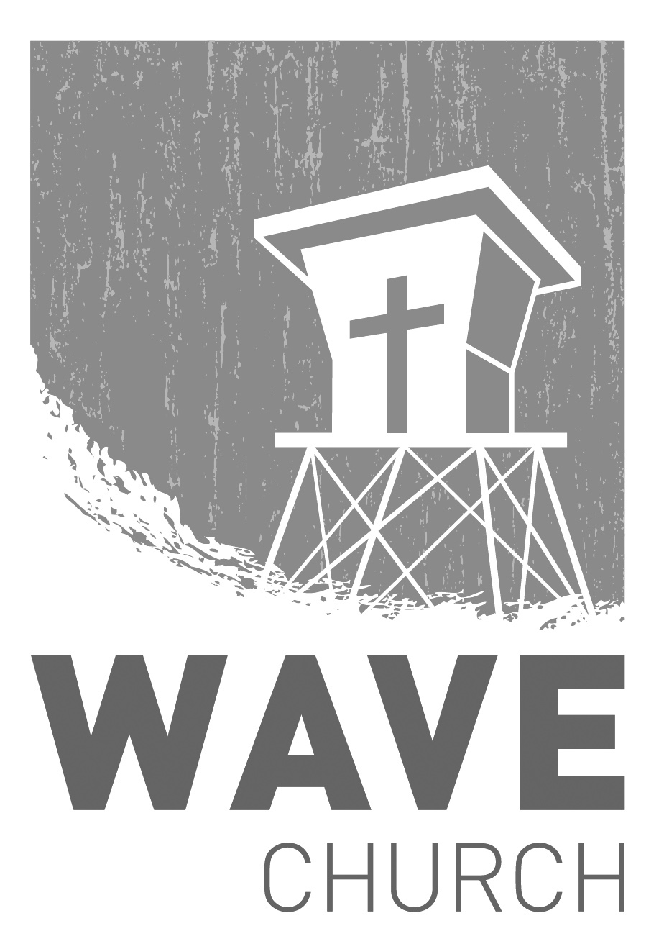
CONNECT.
Connect | Grow | Serve

Wave Church

Welcome to

Sundays at 10 a.m.
Willow Grove Elementary
14727 Via Azul
San Diego, CA | 92127
858-859-2831
Wavechurchsd.com
.
WAVE WEEKLY NEWSLETTER
Want to keep up with all that is going on at Wave? Simply fill out your communication card and write ‘Newsletter’ to get a weekly email update
from Wave!
GROW.
.
SERMON PODCASTS | wavechurchsd.com/sermons/
Summer is in full swing – although no one has told the weather! Many of us
will be traveling and can’t make it to church, but you can still keep up with our sermons online! Want to hear a section again, or send it to a friend? Download our sermon podcasts at http://wavechurchsd.com/sermons/
SERVE.
.
WE NEED YOUR HELP | Serve Teams
We have a few service teams who are looking for more volunteers. Are you part of a serve team yet? Or would you like to try something new? Serving is a great way to make new connections, while making a difference in our church body. Please fill out a connection card with your name and the area you would be willing to serve, and a team leader will be in touch with you!

- Hospitality: Greeters
- Audio/Visual: Slides
- Kids Ministry: Classroom volunteers

