WAVE CHURCH SD | THE WONDER OF CHRISTMAS
HOPE IN THE VALLEY | DEC 1, 2019

CHRISTMAS IS AN ECHO OF ETERNITY

Proverbs 13:12 (ESV) ¹² Hope deferred makes the heart sick, but a desire fulfilled is a tree of life.

Isaiah 7:10-17 (ESV) ¹⁰ Again the Lord spoke to Ahaz: ¹¹ “Ask a sign of the
Lord your God; let it be deep as Sheol or high as heaven.” ¹² But Ahaz said, “I
will not ask, and I will not put the Lord to the test.” ¹³ And he said, “Hear then, O house of David! Is it too little for you to weary men, that you weary my God also? ¹⁴ Therefore the Lord himself will give you a sign. Behold, the virgin shall conceive and bear a son, and shall call his name Immanuel. ¹⁵ He shall eat curds and honey when he knows how to refuse the evil and choose the good. ¹⁶ For before the boy knows how to refuse the evil and choose the good, the land whose two kings you dread will be deserted. ¹⁷ The Lord will bring upon you and upon your people and upon your father’s house such days as have not come since the day that Ephraim departed from Judah—the king of Assyria!”

Isaiah 9:2 (ESV) ²The people who walked in darkness have seen a great light; those who dwelt in a land of deep darkness, on them has light shone.

- JESUS HAS TURNED OUR DARKNESS TO LIGHT
Psalms 84:5 (ESV) Blessed are those whose strength is in you, in whose heart are the highways to Zion.

Isaiah 9:3-5 (ESV) ³ You have multiplied the nation; you have increased its joy; they rejoice before you as with joy at the harvest, as they are glad when they divide the spoil. ⁴ For the yoke of his burden, and the staff for his shoulder, the rod of his oppressor, you have broken as on the day of Midian. ⁵ For every boot of the tramping warrior in battle tumult and every garment rolled in blood
will be burned as fuel for the fire.

- JESUS HAS ENDED OUR WAR AND BROUGHT PEACE

  - Romans 5:10-11, Colossians 1:21-23 (ESV)

Isaiah 9:6-7 (ESV) ⁶ For to us a child is born, to us a son is given; and the government shall be upon his shoulder, and his name shall be called Wonderful Counselor, Mighty God, Everlasting Father, Prince of Peace. ⁷ Of the increase of his government and of peace there will be no end, on the throne of David and over his kingdom, to establish it and to uphold it with justice and with righteousness from this time forth and forevermore. The zeal of the Lord of hosts will do this.

- JESUS HAS TURNED OUR BROKENNESS INTO REDEMPTION

  - Colossians 1:13-14 (ESV)

Matthew 1:18-25 (ESV) ¹⁸ Now the birth of Jesus Christ took place in this way. When his mother Mary had been betrothed to Joseph, before they came together she was found to be with child from the Holy Spirit. ¹⁹ And her husband Joseph, being a just man and unwilling to put her to shame, resolved to divorce her quietly. ²⁰ But as he considered these things, behold, an angel of the Lord appeared to him in a dream, saying, “Joseph, son of David, do not fear to take Mary as your wife, for that which is conceived in her is from the Holy Spirit. ²¹ She will bear a son, and you shall call his name Jesus, for he will save his people from their sins.” ²² All this took place to fulfill what the Lord had spoken by the prophet:
²³ “Behold, the virgin shall conceive and bear a son,
and they shall call his name Immanuel”
(which means, God with us). ²⁴ When Joseph woke from sleep, he did as the angel of the Lord commanded him: he took his wife, ²⁵ but knew her not until she had given birth to a son. And he called his name Jesus.

TWO TAKE AWAYS…

- DO NOT GIVE YOUR HOPE TO INADEQUATE IMMANUELS

- WE HAVE THE HOPE OUR WORLD IS LOOKING FOR!

CONNECT.
.
LADIES ORNAMENT EXCHANGE | Dec. 6th
Come join us for a wonderful evening of fellowship, Christmas cheer, and ornament swapping -- and swiping! Please bring either an appetizer or a dessert, and a wrapped ornament for the exchange. Register today via the Newsletter or on our Website at wavechurchsd.com/events.

WAVE WEEKLY NEWSLETTER
Want to keep up with all that is going on at Wave? Simply fill out your communication card and write ‘Newsletter’ to get a weekly email update
from Wave!
GROW.
.
SERMON PODCASTS | wavechurchsd.com/sermons/
Want to hear a sermon again, or share it with a friend or family member? Download our sermon podcasts at wavechurchsd.com/sermons/. Available now, in addition to our podcasts, is a video of the Sunday sermon! Access it on our Website or on the Wave Church SD YouTube channel.
SERVE.
.
CAROLING AT CASA ALDEA | Dec. 8th
We invite you to join us after service on Dec. 8th to spread some Christmas cheer to our neighbors at Casa Aldea Senior Center! We are excited for an opportunity to be a blessing to this community, and know that you will be blessed by this, too. Come sing some of our favorite Christmas songs and help lift the spirits of people who are in need of God’s light and love this season. We will walk over together as a group immediately following our church service.

GIFTS TO ROMANIAN ORPHANS | Dec. 15th
Every child deserves to smile at Christmas, and at Wave, we want to do our part to make that happen by sending gifts to the orphans in Romania. Gift giving is easy: simply pick up your jumbo Ziploc bag (or bags!) and a gift suggestion sheet at church, and fill that bag with goodies for a girl or boy, ages 4-18. Get your kids and family involved by shopping together, and possibly including a hand-written card or drawing. Please return your bag(s) to church by Dec. 15th.

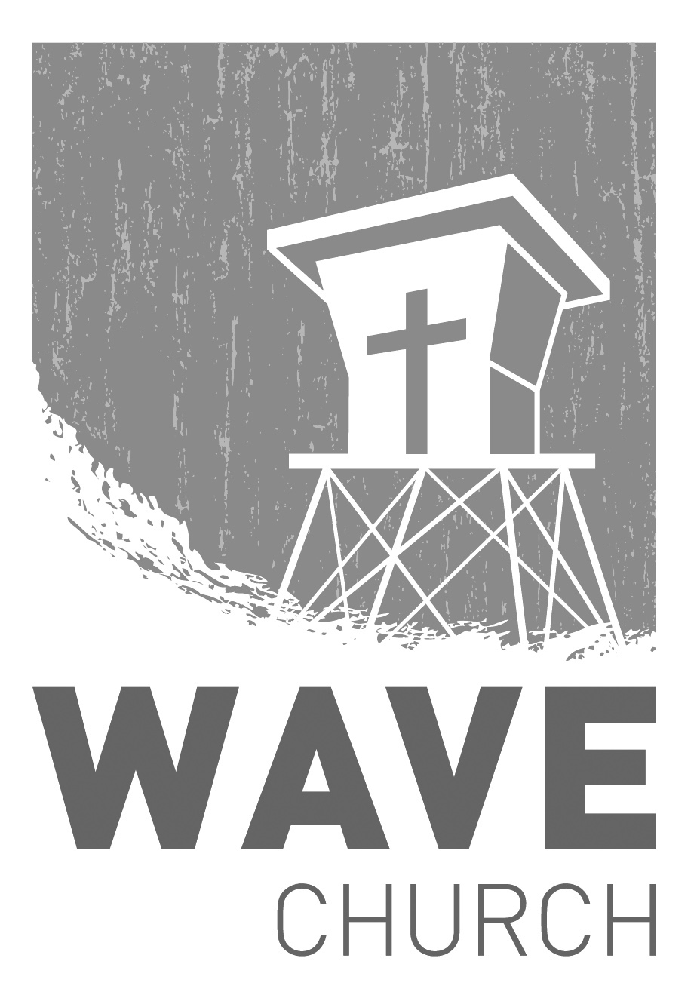
Wave Church

Welcome to

Connect | Grow | Serve

Sundays at 10 a.m.
Willow Grove Elementary
14727 Via Azul
San Diego, CA | 92127
858-859-2831
Wavechurchsd.com

