WAVE CHURCH SD | THE WONDER OF CHRISTMAS
PROMISES ON THE JOURNEY | DEC 8, 2019

THE LEAST LIKELY CHARACTERS ALWAYS
FIND A PLACE IN GOD’S STORY.

Isaiah 7:14 (ESV) ¹⁴ Therefore the Lord himself will give you a sign. Behold, the virgin shall conceive and bear a son, and shall call his name Immanuel.

Luke 2:1-5 (ESV) In those days a decree went out from Caesar Augustus that all the world should be registered. ² This was the first registration when Quirinius was governor of Syria. ³ And all went to be registered, each to his own town. ⁴ And Joseph also went up from Galilee, from the town of Nazareth, to Judea, to the city of David, which is called Bethlehem, because he was of the house and lineage of David, ⁵ to be registered with Mary, his betrothed, who was with child.

THE WONDER OF CHRISTMAS IS FOUND IN OUR DISCOMFORTS AND DIFFICULTIES.

Micah 5:2 (ESV) ² But you, O Bethlehem Ephrathah, who are too little to be among the clans of Judah, from you shall come forth for me one who is to be ruler in Israel, whose coming forth is from of old, from ancient days.

Luke 2:6-7 (ESV) ⁶ And while they were there, the time came for her to give birth. ⁷ And she gave birth to her firstborn son and wrapped him in swaddling cloths and laid him in a manger, because there was no place for them in the inn.

THE WONDER OF CHRISTMAS IS FOUND
IN OUR HUMILIATION.

1 Corinthians 1:27-31 (ESV) ²⁷ But God chose what is foolish in the world to shame the wise; God chose what is weak in the world to shame the strong; ²⁸ God chose what is low and despised in the world, even things that are not, to bring to nothing things that are, ²⁹ so that no human being might boast in the presence of God. ³⁰ And because of him you are in Christ Jesus, who became to us wisdom from God, righteousness and sanctification and redemption, ³¹ so that, as it is written, “Let the one who boasts, boast in the Lord.”

GOD KEEPS HIS PROMISES.

THE PROMISES OF GOD ARE AN ANCHOR OF CONFIDENCE IN THE MIDST OF MY MESSY WORLD.

TWO REASONS WHY THEY ARE NOT…

- I AM IGNORANT ABOUT WHAT GOD HAS PROMISED

- I DO NOT THINK I NEED THEM

TWO TAKEAWAYS…

- GOD IS NOT DONE YET!

Philippians 2:1-11 (ESV) So if there is any encouragement in Christ, any comfort from love, any participation in the Spirit, any affection and sympathy, ² complete my joy by being of the same mind, having the same love, being in full accord and of one mind. ³ Do nothing from selfish ambition or conceit, but in humility count others more significant than yourselves. ⁴ Let each of you look not only to his own interests, but also to the interests of others. ⁵ Have this mind among yourselves, which is yours in Christ Jesus, ⁶ who, though he was in the form of God, did not count equality with God a thing to be grasped, ⁷ but emptied himself, by taking the form of a servant, being born in the likeness of men. ⁸ And being found in human form, he humbled himself by becoming obedient to the point of death, even death on a cross. ⁹ Therefore God has highly exalted him and bestowed on him the name that is above every name, ¹⁰ so that at the name of Jesus every knee should bow, in heaven and on earth and under the earth, ¹¹ and every tongue confess that Jesus Christ is Lord, to the glory of God the Father.

- JESUS’ LOVE SHINES BRIGHTEST WHEN HIS FOLLOWERS
WALK IN HUMILITY.
CONNECT.
.
WAVE WEEKLY NEWSLETTER
Want to keep up with all that is going on at Wave? Simply fill out your communication card and write ‘Newsletter’ to get a weekly email update
from Wave!
GROW.
.
SERMON PODCASTS | wavechurchsd.com/sermons/
Want to hear a sermon again, or share it with a friend or family member? Download our sermon podcasts at wavechurchsd.com/sermons/. Available now, in addition to our podcasts, is a video of the Sunday sermon! Access it on our Website or on the Wave Church SD YouTube channel.
SERVE.
.
CAROLING AT CASA ALDEA | TODAY!
We invite you to join us after service today to spread some Christmas cheer to our neighbors at Casa Aldea Senior Center! We are excited for an opportunity to be a blessing to this community, and know that you will be blessed by this, too. Come sing some of our favorite Christmas songs and help lift the spirits of people who need God’s light and love this season. We will walk over together as a group immediately following our church service.

GIFTS TO ROMANIAN ORPHANS | Dec. 15th
Every child deserves to smile at Christmas, and at Wave, we want to do our part to make that happen by sending gifts to the orphans in Romania. Gift giving is easy: simply pick up your jumbo Ziploc bag (or bags!) and a gift suggestion sheet at church, and fill that bag with goodies for a girl or boy, ages 4-18. Get your kids and family involved by shopping together, and possibly including a hand-written card or drawing. Please return your bag(s) to church by Dec. 15th.

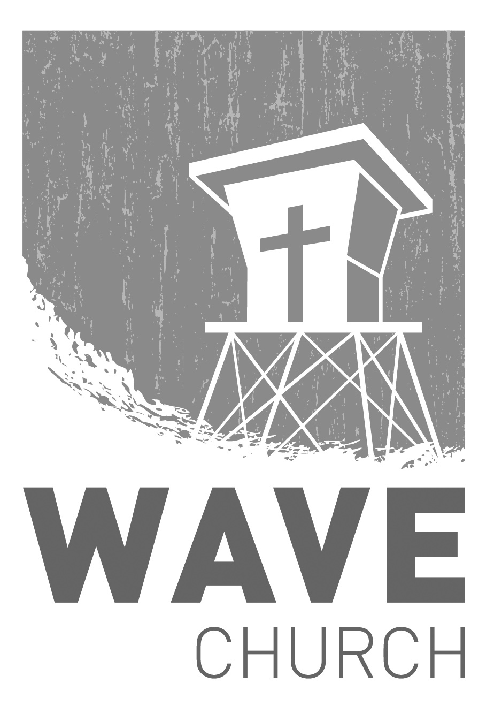
Wave Church

Welcome to

Connect | Grow | Serve

Sundays at 10 a.m.
Willow Grove Elementary
14727 Via Azul
San Diego, CA | 92127
858-859-2831
Wavechurchsd.com

