THE VOW | THE VOW OF PRIORITY
WAVE CHURCH SD | FEB. 10, 2019

GOD CREATED MY MARRIAGE TO THRIVE

FOUR VOWS

- THE VOW OF PRIORITY

- THE VOW OF PURSUIT

- THE VOW OF PARTNERSHIP

- THE VOW OF PURITY

THE VOW OF PRIORITY

GOD IS MY ONE, MY SPOUSE IS MY TWO

Matthew 22:35-37(ESV) ³⁵ And one of them, a lawyer, asked him a question to test him. ³⁶ “Teacher, which is the great commandment in the Law?” ³⁷ And he said to him, “You shall love the Lord your God with all your heart and with all your soul and with all your mind.

SINGLE: I WILL SEEK THE ONE WHILE PREPARING FOR MY TWO
“Become the person who the person you are looking
for is looking for.” Andy Stanley
MARRIED: I PROMISE GOD WILL BE MY FIRST PRIORTY, AND MY SPOUSE WILL BE MY SECOND.
Genesis 2:18-25(ESV) ¹⁸ Then the Lord God said, “It is not good that the man should be alone; I will make him a helper fit for him.” ¹⁹ Now out of the ground the Lord God had formed every beast of the field and every bird of the heavens and brought them to the man to see what he would call them. And whatever the man called every living creature, that was its name. ²⁰ The man gave names to all livestock and to the birds of the heavens and to every beast of the field. But for Adam there was not found a helper fit for him. ²¹ So the Lord God caused a deep sleep to fall upon the man, and while he slept took one of his ribs and closed up its place with flesh. ²² And the rib that the Lord God had taken from the man he made into a woman and brought her to the man. ²³ Then the man said, “This at last is bone of my bones and flesh of my flesh; she shall be called Woman, because she was taken out of Man.” ²⁴ Therefore a man shall leave his father and his mother and hold fast to his wife, and they shall become one flesh. ²⁵ And the man and his wife were both naked and were not ashamed.

WHEN WE MAKE OUR SPOUSE OUR ONE, WE WILL EITHER IDOLIZE OR DEMONIZE THEM.
WE HAVE TO STOP ASKING OF OUR MARRIAGE WHAT GOD NEVER DESIGNED IT TO GIVE.

James 4:5 (ESV) Or do you suppose it is to no purpose that the Scripture says, “He yearns jealously over the spirit that he has made to dwell in us”?

IT’S OFTEN NOT THE BIG THINGS; IT’S THE GOOD THINGS
THAT GET OUT OF PRIORITY.

PROTECT THE PRIORITIES | Proverbs 3:6

- PROTECT YOUR GOD SPACE

- PURSUE GOD TOGETHER

- PROTECT YOUR MARRIAGE FROM THE KIDS

CONNECT.
.
STARTING POINT | Feb. 10th
Our next Starting Point lunch is on Feb. 10th, right after church. If you would like to learn more about Wave, meet our pastors, staff, and other newcomers, then join us for a family meal, and hear about the story and heart of our church.

CONNECT SUNDAY | Feb. 24th
Hey, Wave, let’s get together for some fellowship and tacos! Join us right after service for a chance to connect with our Wave family, get to know someone new, and enjoy a meal together.
Connect | Grow | Serve

WAVE WEEKLY NEWSLETTER
Want to keep up with all that is going on at Wave? Simply fill out your communication card and write ‘Newsletter’ to get a weekly email update
from Wave!

GROW.
.
LIFE GROUP STUDY GUIDE | wavechurchsd.com/study/
Our Life Group Study Guides are available online! The study guide will help you unpack what you heard on Sunday, while diving deeper into God's word during your group discussions, or as a time of personal reflection.
http://wavechurchsd.com/study/
SERVE.
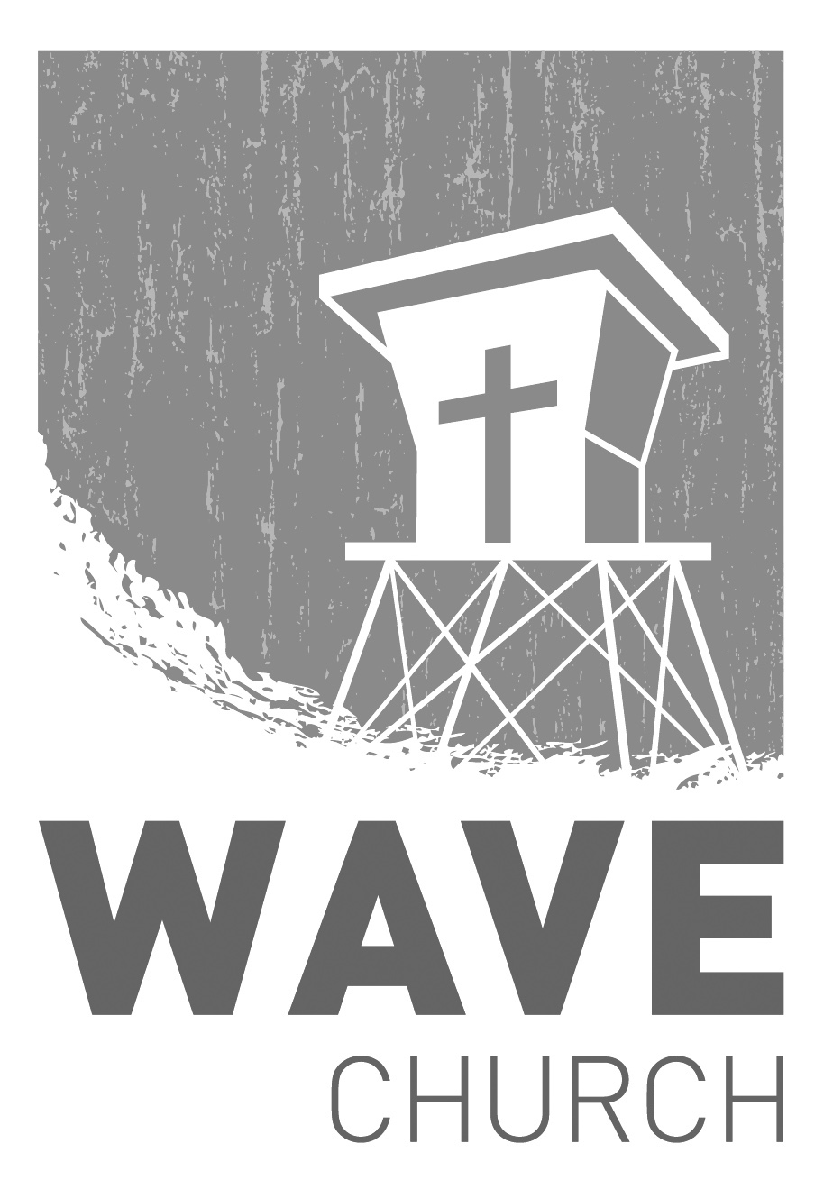
.
DIAPER AND DETERGENT DRIVE | February
Sundays at 10 a.m.
Willow Grove Elementary
14727 Via Azul
San Diego, CA | 92127
858-859-2831
Wavechurchsd.com
We are partnering with Caleb Hardy, who is organizing a community service project at his school, to provide diapers and laundry detergent to Door of Faith Orphanage. We invite you to join us in this effort and help serve the children of Door of Faith with boxes of diapers (all sizes except newborn), and any type of laundry detergent. Please bring your donations to church any Sunday in February.

ROMANIA MISSIONS | Summer
Have you ever considered serving others by going on a missions trip? If you
are interested in joining our Romania Missions Team, or would like more information for you or your family, please contact Steven Perez at steven@wavechurchsd.com.
Wave Church

Welcome to

