COLOSSIANS | JESUS AND HIS CHURCH
Colossians 1:18-29 | JULY 28, 2019

Matthew 27:50-54 (ESV) ⁵⁰ And Jesus cried out again with a loud voice and yielded up his spirit. ⁵¹ And behold, the curtain of the temple was torn in two, from top to bottom. And the earth shook, and the rocks were split. ⁵² The tombs also were opened. And many bodies of the saints who had fallen asleep were raised, ⁵³ and coming out of the tombs after his resurrection they went into the holy city and appeared to many. ⁵⁴ When the centurion and those who were with him, keeping watch over Jesus, saw the earthquake and what took place, they were filled with awe and said, “Truly this was the Son of God!”

JESUS HAS DEMOLISHED EVERY WALL BETWEEN GOD AND MAN.

Ephesians 2:14-16 (NLT) ¹⁴ For Christ himself has brought peace to us. He united Jews and Gentiles into one people when, in his own body on the cross, he broke down the wall of hostility that separated us. ¹⁵ He did this by ending the system of law with its commandments and regulations. He made peace between Jews and Gentiles by creating in himself one new people from the two groups. ¹⁶ Together as one body, Christ reconciled both groups to God by means of his death on the cross, and our hostility toward each other was put to death.

Matthew 16:17-19 (ESV) ¹⁷ And Jesus answered him, “Blessed are you, Simon Bar-Jonah! For flesh and blood has not revealed this to you, but my Father who is in heaven. ¹⁸ And I tell you, you are Peter, and on this rock I will build my church, and the gates of hell shall not prevail against it. ¹⁹ I will give you the keys of the kingdom of heaven, and whatever you bind on earth shall be bound in heaven, and whatever you loose on earth shall be loosed in heaven.”

THE CHURCH EXISTS TO GLORIFY JESUS BY DEMOLISHING
EVERY WALL THAT SEPARATES.

Colossians 1:18-20 (ESV) ¹⁸ And he is the head of the body, the church. He is
the beginning, the firstborn from the dead, that in everything he might be preeminent. ¹⁹ For in him all the fullness of God was pleased to dwell, ²⁰ and through him to reconcile to himself all things, whether on earth or in heaven, making peace by the blood of his cross.

THE CHURCH IS THE NEW TEMPLE | THE MESSAGE: ALL ARE WELCOME.
1 Corinthians 3:16 (ESV) ¹⁶ Do you not know that you are God’s temple and that God’s Spirit dwells in you?

Colossians 1:21-22 (ESV) ²¹ And you, who once were alienated and hostile in mind, doing evil deeds, ²² he has now reconciled in his body of flesh by his death, in order to present you holy and blameless and above reproach before him…

THREE CONSEQUENCES FOR JESUS’ CHURCH

- I AM HOLY IN HIS SIGHT

- I AM WITHOUT BLEMISH

- I AM FREE FROM ACCUSATION

MY JOB IS TO GET PEOPLE TO JESUS.
JESUS’ JOB IS TO DO THE TRANSFORMING.

THREE MARKS OF THE CHURCH

Colossians 1:23 (ESV) ²³ if indeed you continue in the faith, stable and steadfast, not shifting from the hope of the gospel that you heard, which has been proclaimed in all creation under heaven, and of which I, Paul, became a minister.

- THE CHURCH STAYS WITH JESUS

Colossians 1:24-26 (ESV) ²⁴ Now I rejoice in my sufferings for your sake, and in my flesh I am filling up what is lacking in Christ’s afflictions for the sake of his body, that is, the church, ²⁵ of which I became a minister according to the stewardship from God that was given to me for you, to make the word of God fully known, ²⁶ the mystery hidden for ages and generations but now revealed to his saints.

- THE CHURCH SUFFERS WITH JESUS

Colossians 1:27-29 (ESV) ²⁷ To them God chose to make known how great among the Gentiles are the riches of the glory of this mystery, which is Christ in you, the hope of glory. ²⁸ Him we proclaim, warning everyone and teaching everyone with all wisdom, that we may present everyone mature in Christ. ²⁹ For this I toil, struggling with all his energy that he powerfully works within me.

- THE CHURCH SERVES WITH JESUS
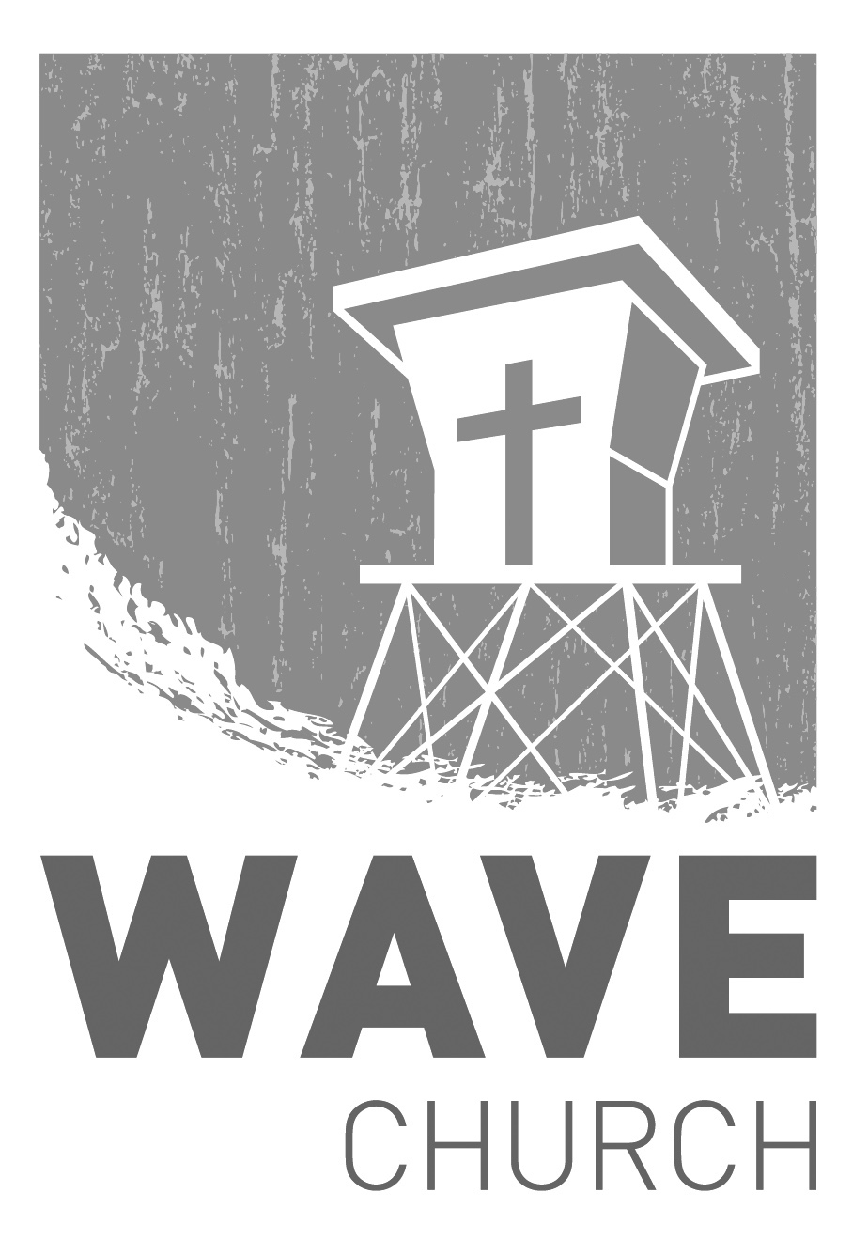
CONNECT.
Connect | Grow | Serve

Wave Church

Welcome to

Sundays at 10 a.m.
Willow Grove Elementary
14727 Via Azul
San Diego, CA | 92127
858-859-2831
Wavechurchsd.com
.
WAVE WEEKLY NEWSLETTER
Want to keep up with all that is going on at Wave? Simply fill out your communication card and write ‘Newsletter’ to get a weekly email update
from Wave!
GROW.
.
SERMON PODCASTS | wavechurchsd.com/sermons/
Summer is in full swing – although no one has told the weather! Many of us
will be traveling and can’t make it to church, but you can still keep up with our sermons online! Want to hear a section again, or send it to a friend? Download our sermon podcasts at http://wavechurchsd.com/sermons/
SERVE.
.
THE GREAT BACKPACK GIVE | Now – Aug. 4th
We started our summer service project and would love for you to partner with us in our backpack drive to bless the orphans at Door of Faith! The big ask was for 100 backpacks, and WE CAN DO IT! Details are available on the Website, or click the link in the Newsletter for easy access to all the information.
WAVE FAMILY CAMP | Aug. 8-10, 2019
We will be traveling to La Misión, Mexico for a two-night, three-day family missions trip at Door of Faith Orphanage. During our time there, we will be spending time with the kids, serving meals, and helping prepare a space for Door of Faith's new school! Making quality connections is what missions are all about, so please bring your whole family! For more information, and to register, check the Newsletter or visit our website. Hope to see you there!
WE NEED YOUR HELP | Serve Teams
We have a few service teams who are looking for more volunteers. Are you part of a serve team yet? Or would you like to try something new? Serving is a great way to make new connections, while making a difference in our church body. Please fill out a connection card with your name and the area you would be willing to serve, and a team leader will be in touch with you!

- Hospitality: Greeters
- Audio/Visual: Slides
- Kids Ministry: Classroom volunteers

