CHASING CARROTS | MONEY AND STUFF
WAVE CHURCH SD | JAN. 5, 2019

IF I COULD HAVE JUST A LITTE BIT
MORE ___________, THEN I'D BE HAPPY.

Luke 12:13-21 (NIV) ¹³ Someone in the crowd said to him, “Teacher, tell my brother to divide the inheritance with me.” ¹⁴ Jesus replied, “Man, who appointed me a judge or an arbiter between you?” ¹⁵ Then he said to them, “Watch out! Be on your guard against all kinds of greed; life does not consist in an abundance of possessions.” ¹⁶ And he told them this parable: “The ground of a certain rich man yielded an abundant harvest. ¹⁷ He thought to himself, ‘What shall I do? I have no place to store my crops.’ ¹⁸ “Then he said, ‘This is what I’ll do. I will tear down my barns and build bigger ones, and there I will store my surplus grain. ¹⁹ And I’ll say to myself, “You have plenty of grain laid up for many years. Take life easy; eat, drink and be merry.” ’ ²⁰ “But God said to him, ‘You fool! This very night your life will be demanded from you. Then who will get what you have prepared for yourself?’ ²¹ “This is how it will be with whoever stores up things for themselves but is not rich toward God.”

AM I RICH TOWARD GOD?

GOOD NEWS: I AM RICH

Ecclesiastes 5:19 (NIV) ¹⁹ Moreover, when God gives someone wealth and possessions, and the ability to enjoy them, to accept their lot and be happy in their toil—this is a gift of God.

BAD NEWS: I AM RICH

Mark 10:17-27 (NIV) ¹⁷ As Jesus started on his way, a man ran up to him and fell on his knees before him. “Good teacher,” he asked, “what must I do to inherit eternal life?” ¹⁸ “Why do you call me good?” Jesus answered. “No one is good—except God alone. ¹⁹ You know the commandments: ‘You shall not murder, you shall not commit adultery, you shall not steal, you shall not give false testimony, you shall not defraud, honor your father and mother.’” ²⁰ “Teacher,” he declared, “all these I have kept since I was a boy.” ²¹ Jesus looked at him and loved him. “One thing you lack,” he said. “Go, sell everything you have and give to the poor, and you will have treasure in heaven. Then come, follow me.” ²² At this the man’s face fell. He went away sad, because he had great wealth. ²³ Jesus looked around and said to his disciples, “How hard it is for the rich to enter the kingdom of God!” ²⁴ The disciples were amazed at his words. But Jesus said again, “Children, how hard it is to enter the kingdom of God! ²⁵ It is easier for a camel to go through the eye of a needle than for someone who is rich to enter the kingdom of God.” ²⁶ The disciples were even more amazed, and said to each other, “Who then can be saved?” ²⁷ Jesus looked at them and said, “With man this is impossible, but not with God; all things are possible with God.”

SPIRITUAL DISADVANTAGES OF WEALTH

- I DON’T SEE MY NEED FOR GOD

- I AM DISTRACTED BY MY MONEY AND MY STUFF

- I WILL BE HELD ACCOUNTABLE

- I WILL BE SPIRITUALLY ATTACKED

Matthew 6:24 (ESV) ²⁴ “No one can serve two masters, for either he will hate the one and love the other, or he will be devoted to the one and despise the other. You cannot serve God and money.

WE DON'T NEED MORE OF WHAT IS TEMPORARY;
WE NEED MORE OF WHAT IS ETERNAL.

1 Timothy 6:17-19 (NIV) ¹⁷ Command those who are rich in this present world not to be arrogant nor to put their hope in wealth, which is so uncertain, but to put their hope in God, who richly provides us with everything for our enjoyment. ¹⁸ Command them to do good, to be rich in good deeds, and to be generous and willing to share. ¹⁹ In this way they will lay up treasure for themselves as a firm foundation for the coming age, so that they may take hold of the life that is truly life.

GOD HAS BLESSED ME WITH MORE THAN I NEED. I AM RICH.

I WILL NOT TRUST IN MY RICHES, BUT WILL TRUST IN HIM WHO
RICHLY PROVIDES.

BECAUSE I HAVE MORE, I WILL GIVE MORE AND DO MORE.
CONNECT.
.
CONNECT SUNDAY | Jan. 26th
Hey, Wave, let’s start 2020 right and get together for some fellowship and tacos! Join us right after service for a chance to connect with our Wave family, get to know someone new, and enjoy a meal together.
WAVE WEEKLY NEWSLETTER
Want to keep up with all that is going on at Wave? Simply fill out your communication card and write ‘Newsletter’ to get a weekly email update
from Wave!
STARTING POINT LUNCH | Feb. 9th
Starting Point is our “You are here” sign at Wave, and this lunch is designed to make it easy for you to navigate your next steps to connect, grow, and serve at Wave Church. If you would like to learn more about Wave, meet our pastors, staff, and other newcomers, and hear about the story and heart of our church, please fill out a Communication Card, check Starting Point, and drop it in the offering box in the back.
GROW.
.
LIFE GROUPS | Jan. 12th
Happy New Year! Our first 2020 Life Group session kicks off next week! If you are not part of a Life Group, but would like to grow deeper in your relationship with God and other members of our church family, please fill out a Life Group info card, and a Life Group leader will be in touch with you.
SERMON PODCASTS | wavechurchsd.com/sermons/
Want to hear a sermon again, or share it with a friend or family member? Download our sermon podcasts at wavechurchsd.com/sermons/. Available now, in addition to our podcasts, is a video of the Sunday sermon! Access it on our Website or on the Wave Church SD YouTube channel.
SERVE.
.
HOW CAN YOU HELP? | Serve Teams
We have many service opportunities here at Wave that are always happy to welcome more volunteers. Are you part of a serve team yet? Serving is a great way to make new connections, while making a difference in our church body. Please fill out a Communication Card with your name and an area you would be willing to serve, and a team leader will be in touch with you!
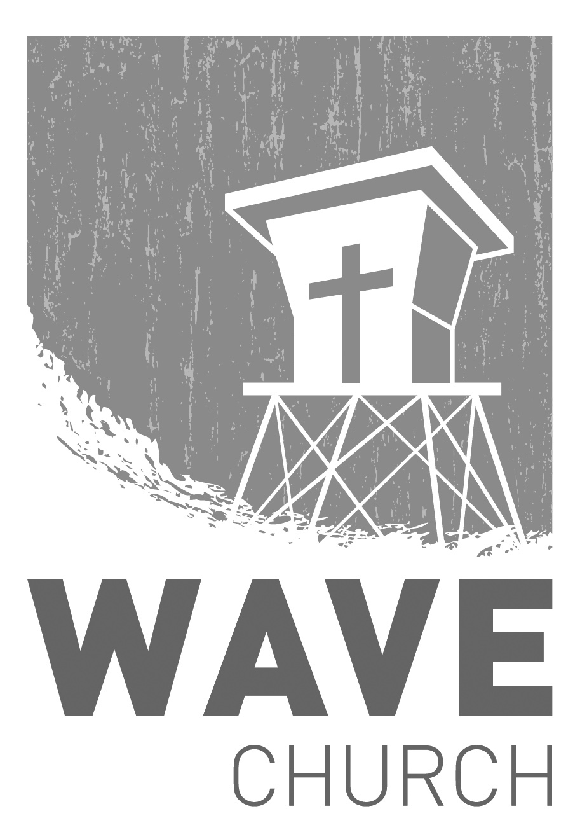
Wave Church

Welcome to

Connect | Grow | Serve

Sundays at 10 a.m.
Willow Grove Elementary
14727 Via Azul
San Diego, CA | 92127
858-859-2831
Wavechurchsd.com

