CHASING CARROTS | PERFECTIONISM
WAVE CHURCH SD | JAN. 12, 2019

IF I COULD JUST BE MORE ___________, THEN I'D BE HAPPY.

Matthew 5:48 (ESV) ⁴⁸ You therefore must be perfect, as your heavenly Father is perfect.

THREE TYPES OF PERFECTIONISTS

- SELF-ORIENTED PERFECTIONIST – You hold unrealistically high expectations of yourself, battle with feelings of guilt, and struggle with
deep feelings of inadequacy.

- EXTERNALLY-ORIENTED PERFECTIONIST – You believe others expect you to be perfect. You wear yourself out trying to meet others’ expectations. You often feel alone, depressed, and desperate because you believe you will never be enough.

- OTHERS-ORIENTED PERFECTIONIST – You expect others to live up to your impossible standards. When others fail to meet your expectations, you grow irritable, abrasive, passive aggressive, and distant.

PERFECTIONISM IS A COVERING FOR OUR SINFULNESS

Genesis 3:7-10 (ESV) ⁷ Then the eyes of both were opened, and they knew that they were naked. And they sewed fig leaves together and made themselves loincloths. ⁸ And they heard the sound of the Lord God walking in the garden in the cool of the day, and the man and his wife hid themselves from the presence of the Lord God among the trees of the garden. ⁹ But the Lord God called to the man and said to him, “Where are you?” ¹⁰ And he said, “I heard the sound of you in the garden, and I was afraid, because I was naked, and I hid myself.”

2 Corinthians 3:13 (NIV) ¹³ We are not like Moses, who would put a veil over his face to prevent the Israelites from seeing the end of what was passing away.

Romans 3:20 (ESV) ²⁰ For no one can ever be made right with God by doing what the law commands. The law simply shows us how sinful we are.

Jeremiah 17:9 (NLT) ⁹ “The human heart is the most deceitful of all things, and desperately wicked. Who really knows how bad it is?

Romans 3:23 (NLT) ²³ For everyone has sinned; we all fall short of God’s glorious standard.

UNTIL YOU SEE YOURSELF AS A SINNER,
YOU WON’T SEE YOUR NEED FOR A SAVIOR.

“I think that if God forgives us we must forgive ourselves. Otherwise, it is almost like setting up ourselves as a higher tribunal than Him.” – C.S. Lewis

Romans 3:22 (NLT) ²² We are made right with God by placing our faith in Jesus Christ. And this is true for everyone who believes, no matter who we are.

BECAUSE OF JESUS, THE PRESSURE IS OFF!

- CHOOSE PEOPLE OVER PERFECTION

Luke 10:41-42 (NLT) ⁴¹ “My dear Martha, you are worried and upset over all these details! ⁴² There is only one thing worth being concerned about. Mary has discovered it, and it will not be taken away from her.”

- CHOOSE PERFECT LOVE OVER PERFECT PERFORMANCE

Matthew 5:43-48 (ESV) ⁴³ “You have heard that it was said, ‘You shall love your neighbor and hate your enemy.’ ⁴⁴ But I say to you, Love your enemies and pray for those who persecute you, ⁴⁵ so that you may be sons of your Father who is in heaven. For he makes his sun rise on the evil and on the good, and sends rain on the just and on the unjust. ⁴⁶ For if you love those who love you, what reward do you have? Do not even the tax collectors do the same? ⁴⁷ And if you greet only your brothers, what more are you doing than others? Do not even the Gentiles do the same? ⁴⁸ You therefore must be perfect, as your heavenly Father is perfect.

PERFECT = MATURE
CONNECT.
.
CONNECT SUNDAY | Jan. 26th
Hey, Wave, let’s start 2020 right and get together for some fellowship and tacos! Join us right after service for a chance to connect with our Wave family, get to know someone new, and enjoy a meal together.
WAVE WEEKLY NEWSLETTER
Want to keep up with all that is going on at Wave? Simply fill out your communication card and write ‘Newsletter’ to get a weekly email update
from Wave!
STARTING POINT LUNCH | Feb. 9th
Starting Point is our “You are here” sign at Wave, and this lunch is designed to make it easy for you to navigate your next steps to connect, grow, and serve at Wave Church. If you would like to learn more about Wave, meet our pastors, staff, and other newcomers, and hear about the story and heart of our church, please fill out a Communication Card, check Starting Point, and drop it in the offering box in the back.
GROW.
.
LIFE GROUPS | Jan. 12th
Happy New Year! Our first 2020 Life Group session kicks off this week! If you are not part of a Life Group, but would like to grow deeper in your relationship with God and other members of our church family, please fill out a Life Group info card, and a Life Group leader will be in touch with you.
SERMON PODCASTS | wavechurchsd.com/sermons/
Want to hear a sermon again, or share it with a friend or family member? Download our sermon podcasts at wavechurchsd.com/sermons/. Available now, in addition to our podcasts, is a video of the Sunday sermon! Access it on our Website or on the Wave Church SD YouTube channel.
SERVE.
.
HOW CAN YOU HELP? | Serve Teams
We have many service opportunities here at Wave that are always happy to welcome more volunteers. Are you part of a serve team yet? Serving is a great way to make new connections, while making a difference in our church body. Please fill out a Communication Card with your name and an area you would be willing to serve, and a team leader will be in touch with you!
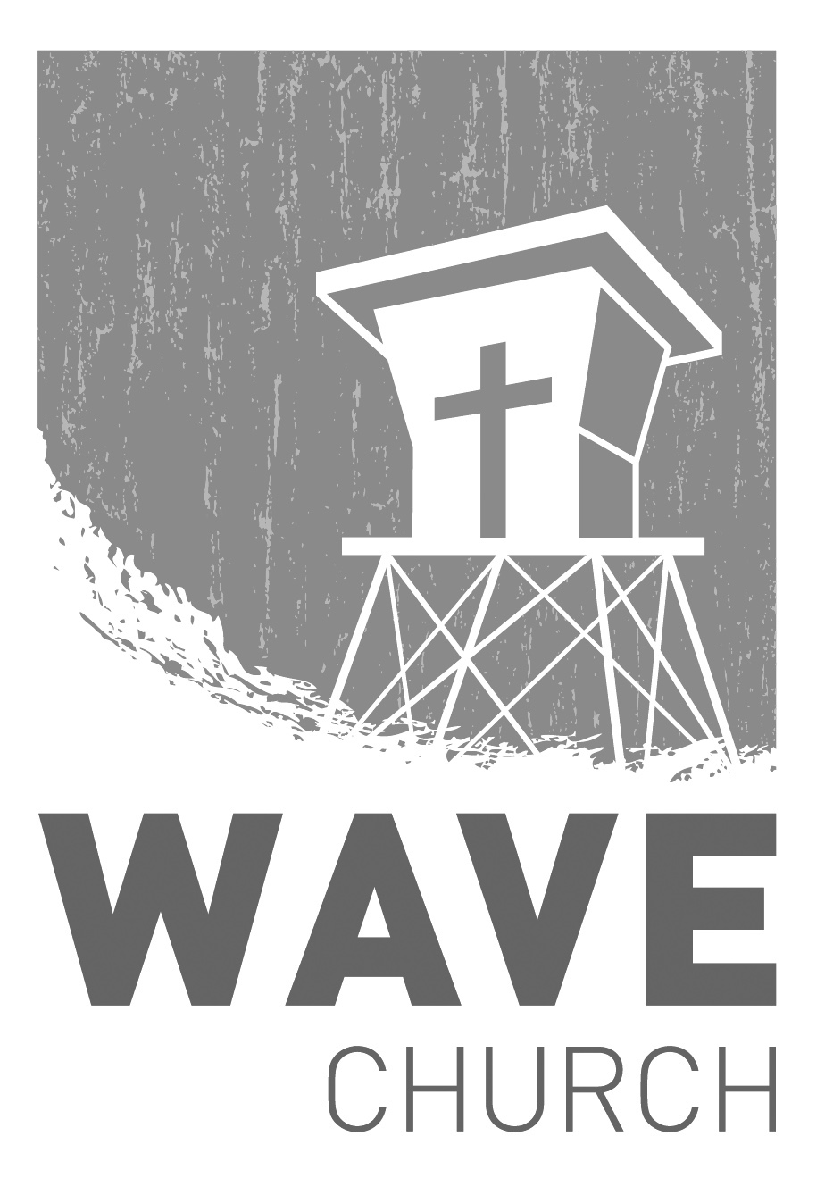
Wave Church

Welcome to

Connect | Grow | Serve

Sundays at 10 a.m.
Willow Grove Elementary
14727 Via Azul
San Diego, CA | 92127
858-859-2831
Wavechurchsd.com

