FEAR NOT | WHY WORRY? PART 2
WAVE CHURCH SD | MAY 10, 2020

WORRY IS A PREOCCUPATION WITH TOMORROW

Matthew 6:27-30 (ESV) ²⁷ And which of you by being anxious can add a single hour to his span of life? ²⁸ And why are you anxious about clothing? Consider the lilies of the field, how they grow: they neither toil nor spin, ²⁹ yet I tell you, even Solomon in all his glory was not arrayed like one of these. ³⁰ But if God so clothes the grass of the field, which today is alive and tomorrow is thrown into the oven, will he not much more clothe you.

Psalm 139:1-6 (ESV) O Lord, you have searched me and known me! ² You know when I sit down and when I rise up; you discern my thoughts from afar. ³ You search out my path and my lying down and are acquainted with all my ways. ⁴ Even before a word is on my tongue, behold, O Lord, you know it altogether. ⁵ You hem me in, behind and before, and lay your hand upon me. ⁶ Such knowledge is too wonderful for me; it is high; I cannot attain it.

GOD KNOWS ME. I AM NOT ALONE IN MY WORRY.

Matthew 6:30 (ESV) …O you of little faith?

THERE IS A RELATIONSHIP BETWEEN THE SIZE OF OUR FAITH
AND THE SIZE OF OUR WORRY

THE ONLY WAY TO GROW THE SIZE OF YOUR FAITH IS TO TRUST GOD IN THE UNCERTAINTIES OF LIFE.

Matthew 6:31-32 (ESV) ³¹ Therefore do not be anxious, saying, ‘What shall we eat?’ or ‘What shall we drink?’ or ‘What shall we wear?’ ³² For the Gentiles seek after all these things, and your heavenly Father knows that you need them all.

What do you want this season to be defined by?

GOD KNOWS WHAT I NEED. I AM WELL CARED FOR.

Matthew 6:33 (ESV) But seek first the kingdom of God and his righteousness, and all these things will be added to you.

Mark 1:14 (ESV) Jesus came into Galilee, proclaiming the gospel of God, ¹⁵ and saying, “The time is fulfilled, and the kingdom of God is at hand; repent and believe in the gospel.”

Matthew 19:16-22 (ESV) ¹⁶ And behold, a man came up to him, saying, “Teacher, what good deed must I do to have eternal life?” ¹⁷ And he said to him, “Why do you ask me about what is good? There is only one who is good. If you would enter life, keep the commandments.” ¹⁸ He said to him, “Which ones?” And Jesus said, “You shall not murder, You shall not commit adultery, You shall not steal, You shall not bear false witness, ¹⁹ Honor your father and mother, and, You shall love your neighbor as yourself.” ²⁰ The young man said to him, “All these I have kept. What do I still lack?” ²¹ Jesus said to him, “If you would be perfect, go, sell what you possess and give to the poor, and you will have treasure in heaven; and come, follow me.” ²² When the young man heard this he went away sorrowful, for he had great possessions.

Matthew 6:19-21, 24 (ESV) ¹⁹ “Do not lay up for yourselves treasures on earth, where moth and rust destroy and where thieves break in and steal, ²⁰ but lay up for yourselves treasures in heaven, where neither moth nor rust destroys and where thieves do not break in and steal. ²¹ For where your treasure is, there your heart will be also. … ²⁴ “No one can serve two masters, for either he will hate the one and love the other, or he will be devoted to the one and despise the other. You cannot serve God and money.

SEEK FIRST GOD’S AGENDA BY SURRENDERING YOUR AGENDA

WORRY IS LIKE PRAYER IN REVERSE

Matthew 6:7-13 (ESV) ⁷ “And when you pray, do not heap up empty phrases as the Gentiles do, for they think that they will be heard for their many words. ⁸ Do not be like them, for your Father knows what you need before you ask him. ⁹ Pray then like this: “Our Father in heaven, hallowed be your name. ¹⁰ Your kingdom come, your will be done, on earth as it is in heaven. ¹¹ Give us this day our daily bread, ¹² and forgive us our debts, as we also have forgiven our debtors. ¹³ And lead us not into temptation, but deliver us from evil.

Matthew 6:33-34 (ESV) ³³ But seek first the kingdom of God and his righteousness, and all these things will be added to you. ³⁴ “Therefore do not be anxious about tomorrow, for tomorrow will be anxious for itself. Sufficient for
the day is its own trouble.

CONNECT.
.
WAVE CHURCH ONLINE | Sundays
During this unprecedented time, it is more important than ever that we remain connected even when we are separated. Join us for Wave Church SD ONLINE Sunday morning at 10 a.m. Visit our Website to access the video link, worship videos from Tiffany and members of our worship team, and a family church reading and activity.
wavechurchsd.com/church-online
WAVE WEEKLY NEWSLETTER
Want to keep up with all that is going on at Wave? Simply fill out your communication card and write ‘Newsletter’ to get a weekly email update
from Wave!
GROW.
.
SERMON PODCASTS | wavechurchsd.com/sermons/
Want to hear a sermon again, or share it with a friend or family member? Download our sermon podcasts at wavechurchsd.com/sermons/. Access it
on our Website or on the Wave Church SD YouTube channel.
SERVE.
.
HOW CAN YOU HELP YOU? | (858) 465-4144
Wave has developed a texting app for you to text us your prayer requests and physical needs over the coming weeks. With many people self-quarantining, there will certainly be needs and shortages of supplies. This is an opportunity to BE THE CHURCH. Please text your need to (858) 465-4144 and we will seek to share our resources with one another and our neighbors.

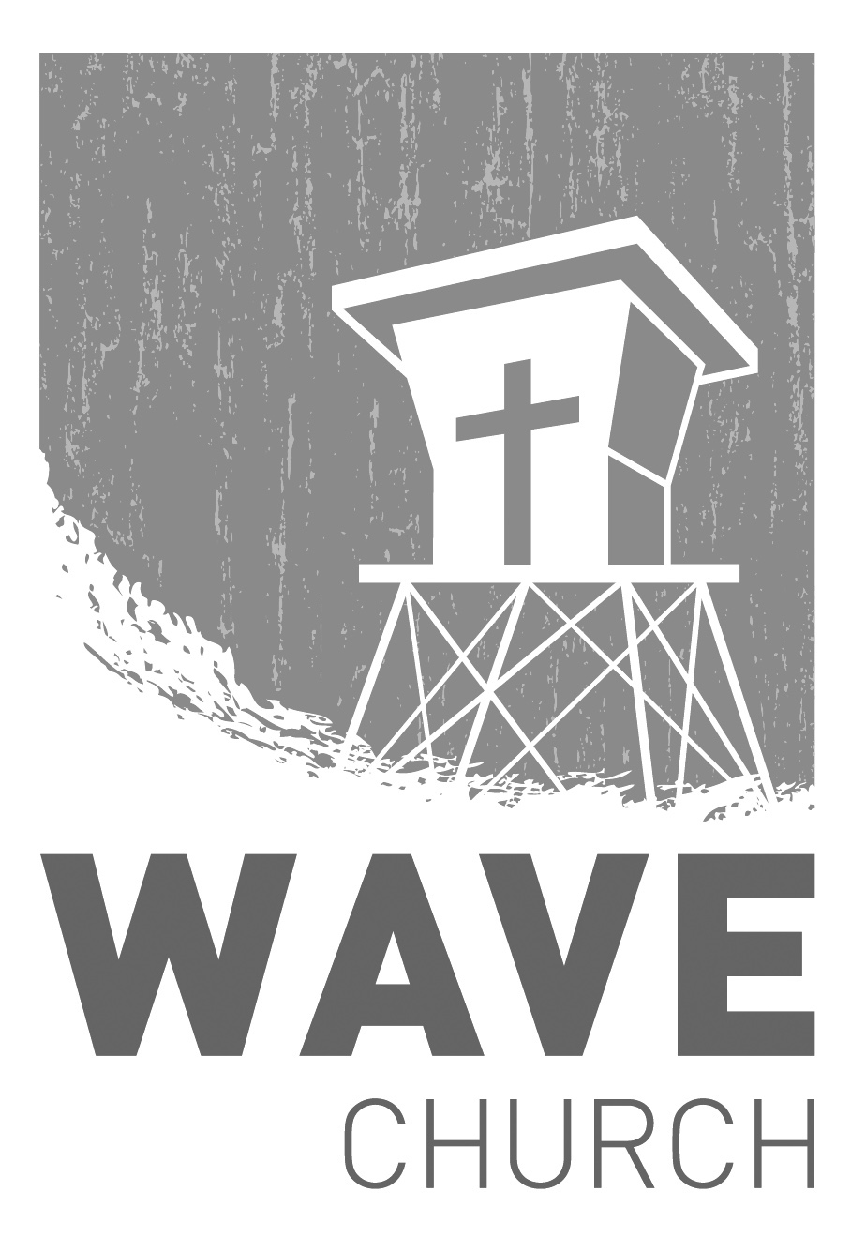
Wave Church

Welcome to

Connect | Grow | Serve

Sundays at 10 a.m.
Willow Grove Elementary
14727 Via Azul
San Diego, CA | 92127
858-859-2831
Wavechurchsd.com

