THE PARABLE OF THE SOILS | MATTHEW 13
WAVE CHURCH SD | MARCH 10, 2019

What is a Parable?

Parable “Parabole” | para = thrown; ballo = beside

- A SPIRITUAL LESSON THROWN ALONGSIDE LIFE AS IT HAPPENS
Matthew 13:3-13 (ESV) ³ And he told them many things in parables, saying:
“A sower went out to sow. ⁴ And as he sowed, some seeds fell along the path, and the birds came and devoured them. ⁵ Other seeds fell on rocky ground, where
they did not have much soil, and immediately they sprang up, since they had no depth of soil, ⁶ but when the sun rose they were scorched. And since they had no root, they withered away. ⁷ Other seeds fell among thorns, and the thorns grew
up and choked them. ⁸ Other seeds fell on good soil and produced grain, some a hundredfold, some sixty, some thirty. ⁹ He who has ears, let him hear.” ¹⁰ Then the disciples came and said to him, “Why do you speak to them in parables?” ¹¹ And he answered them, “To you it has been given to know the secrets of the kingdom of heaven, but to them it has not been given. ¹² For to the one who has, more will be given, and he will have an abundance, but from the one who has not, even what he has will be taken away. ¹³ This is why I speak to them in parables, because seeing they do not see, and hearing they do not hear, nor do they understand.

THE TWO-FOLD PURPOSE OF THE PARABLES:

- HIDE TRUTH FROM THE SELF-RIGHTEOUS

- REVEAL TRUTH TO GENUINE SEEKERS
Matthew 11:25-26 (ESV), 1 Corinthians 2:7-9 (ESV)
Matthew 13:14-17 (ESV) ¹⁴ Indeed, in their case the prophecy of Isaiah is fulfilled that says: “ ‘ “You will indeed hear but never understand, and you will indeed see but never perceive.” ¹⁵ For this people’s heart has grown dull, and with their ears they can barely hear, and their eyes they have closed, lest they should see with their eyes and hear with their ears and understand with their heart and turn, and I would heal them.’ ¹⁶ But blessed are your eyes, for they see, and your ears, for they hear. ¹⁷ For truly, I say to you, many prophets and righteous people longed to see what you see, and did not see it, and to hear what you hear, and did not hear it.
Matthew 13:18-23 (ESV) ¹⁸ “Hear then the parable of the sower: ¹⁹ When anyone hears the word of the kingdom and does not understand it, the evil one comes and snatches away what has been sown in his heart. This is what was sown along the path. ²⁰ As for what was sown on rocky ground, this is the one who hears the word and immediately receives it with joy, ²¹ yet he has no root in himself, but endures for a while, and when tribulation or persecution arises on account of the word, immediately he falls away. ²² As for what was sown among thorns, this is the one who hears the word, but the cares of the world and the deceitfulness of riches choke the word, and it proves unfruitful. ²³ As for what was sown on good soil, this is the one who hears the word and understands it. He indeed bears fruit and yields, in one case a hundredfold, in another sixty, and in another thirty.”

SEED = THE GOSPEL | SOWER = ANYONE | SOIL = THE HEART

LESSON OF THE SOILS:

- MY RESPONSE TO THE WORD OF GOD IS DEPENDENT ON THE CONDITION OF MY HEART.

- THE PATHSIDE HEARER | Prov. 1:7, Jer. 19:15, Acts 7:51
- THE SHALLOW HEARER | John 6:66, Gal. 1:6
- THE WORLDLY HEARER | James 1:8, Luke 16:13, 1 Tim. 6:9-10
- THE FRUITFUL HEARER | John 15:7-8, Gal. 6:9, Heb.10:35-36

HOW DO I BECOME A FRUITFUL HEARER?

ANSWER: ENDURING FAITH PRODUCES UNIMAGINABLE KINGDOM FRUITFULNESS

AS A SOWER, WHAT AM I RESPONSIBLE FOR?

ANSWER: I AM ONLY RESPONSIBLE TO SOW, NOT TO ENSURE A HARVEST
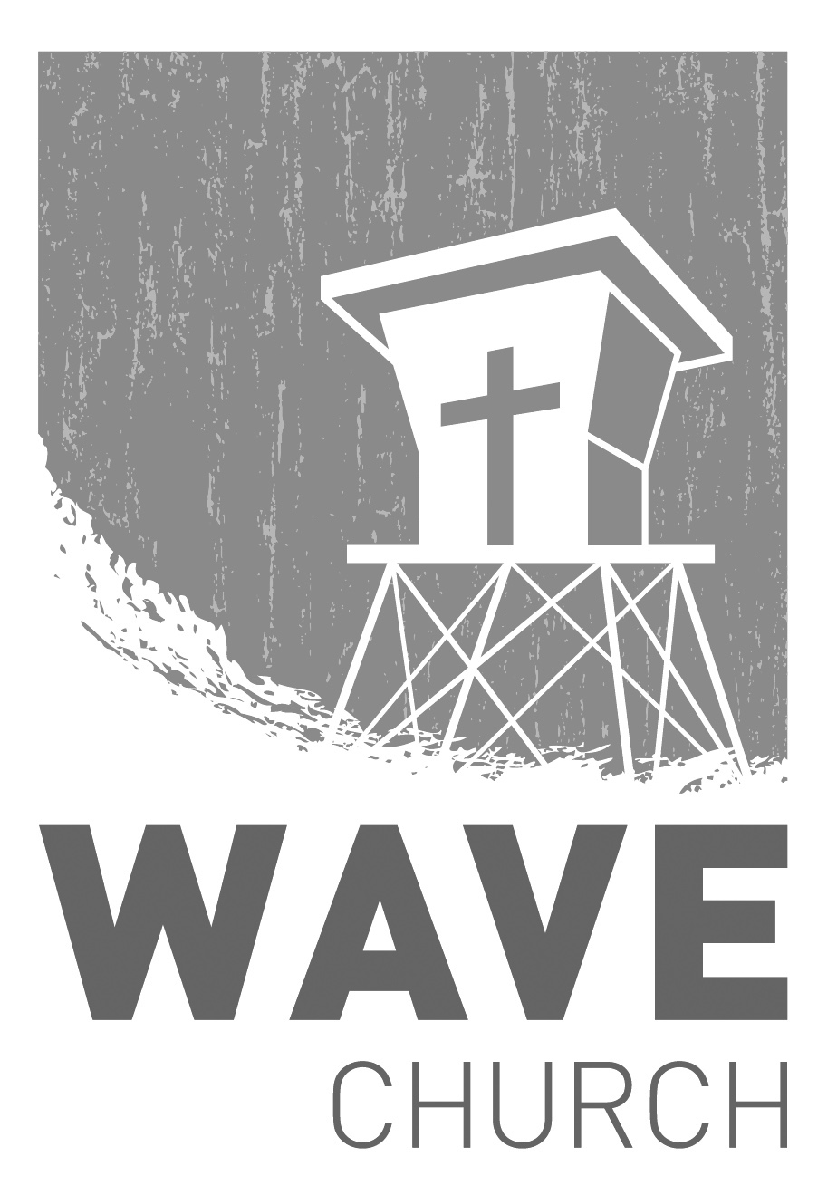
CONNECT.
Connect | Grow | Serve

Sundays at 10 a.m.
Willow Grove Elementary
14727 Via Azul
San Diego, CA | 92127
858-859-2831
Wavechurchsd.com
Wave Church

Welcome to

.
THE PARABLES OF JESUS | Begins Mar. 10th
Everyone loves and unforgettable story, especially when that story captures our hearts, sucks us in, and changes us forever! The Parables of Jesus are famous, unforgettable, and often confusing; yet these spontaneous tales are meant to teach us intentional lessons that have the power to transform. Join
us as we discover the true meaning of the Parables of Jesus.

WAVE WEEKLY NEWSLETTER
Want to keep up with all that is going on at Wave? Simply fill out your communication card and write ‘Newsletter’ to get a weekly email update
from Wave!
GROW.
.
MARRIAGE STRONG CLASS | Begins Mar. 27th
In this four-week class, you will learn to discover the truth about marriage,
and how the past affects your relationships; to identify your conflict patterns, and turn destructive coping into positive interaction with your spouse; and to embrace your personality differences and diverse spiritual gifts, and learn to encourage each other in spiritual and emotional growth. Wednesdays from
7 to 9 p.m. For more information, please fill out a communication card.

LIFE GROUP STUDY GUIDE | wavechurchsd.com/study/
Our Life Group Study Guides are available online! The study guide will help you unpack what you heard on Sunday, while diving deeper into God's word during your group discussions, or as a time of personal reflection.
http://wavechurchsd.com/study/
SERVE.
.
WE NEED YOUR HELP | Serve Teams
We have a few service teams who are looking for more volunteers. Are you part of a serve team yet? Or would you like to try something new? Serving is a great way to make new connections, while making a difference in our church body. Please fill out a connection card with your name and the area you would be willing to serve, and a team leader will be in touch with you!

- Hospitality: Greeters
- Audio/Visual: Slides
- Kids Ministry: Classroom volunteers

