RELATIONSHIP GOALS | COVENANT-KEEPING
WAVE CHURCH SD | MARCH 1, 2020

SATAN WANTS TO RUIN YOUR LIFE BY
RUINING YOUR RELATIONSHIPS.

OPPOSITES ATTRACT, THEN THEY ATTACK.

NORMAL MARRIAGES FIGHT AGAINST EACH OTHER;
GODLY MARRIAGES FIGHT FOR EACH OTHER.

Matthew 19:3-6 (ESV)
³ And Pharisees came up to him and tested him by asking, “Is it lawful to divorce one’s wife for any cause?” ⁴ He answered, “Have you not read that he who created them from the beginning made them male and female, ⁵ and said, ‘Therefore a man shall leave his father and his mother and hold fast to his wife, and the two shall become one flesh’? ⁶ So they are no longer two but one flesh. What therefore God has joined together, let not man separate.”

THREE APPROACHES TO MARRIAGE

- CASUAL APPROACH

A commitment based on convenience

- CONTRACTUAL APPROACH

A contract is built on mutual distrust

- COVENANTAL APPROACH

A covenant is based on mutual commitment

COVENANT | CUTTING

Hebrews 13:4 (ESV)
Marriage should be honored by all, and the marriage bed kept pure, for God will judge the adulterer and all the sexually immoral.

2 Corinthians 5:17 (ESV)
Therefore, if anyone is in Christ, he is a new creation. The old has passed away; behold, the new has come.

Matthew 26:27-28 (ESV)
²⁷ And he took a cup, and when he had given thanks he gave it to them, saying, “Drink of it, all of you, ²⁸ for this is my blood of the covenant, which is poured out for many for the forgiveness of sins.

FROM THIS DAY FORWARD, I COMMIT TO HONOR THE GOD-GIVEN BLESSING OF MY MARRIAGE.

CONNECT.
.
DEFY DRIFT | defydrift.com
Often times in our relationships, we lose the art of conversation because of all the “business items” of life that take over. If you are looking for some great conversation starters for your next date night, road trip, or late evening on the couch, check out these conversation cards for couples at defydrift.com. Their aim is to help couples deliberately defy relational drift by bringing you together through conversation. (Also check out their new parenting conversation deck!)
GROW.
.
MARRIAGE WORKSHOP | Apr. 18th
If you are looking for the next step to take in your marriage, sign up for our one-day marriage workshop on Saturday, April 18th. We will be meeting from 10 a.m. to 3 p.m., and lunch will be served. Please see the registration link in the newsletter or on our website at wavechurchsd.com/events.
SERMON PODCASTS | wavechurchsd.com/sermons/
Want to hear a sermon again, or share it with a friend or family member? Download our sermon podcasts at wavechurchsd.com/sermons/. Available now, in addition to our podcasts, is a video of the Sunday sermon! Access it on our Website or on the Wave Church SD YouTube channel.
SERVE.
.
MEDICAL MISSION TRIP | Mar. 19th
Calling all medical professionals! Wave is taking a serve team to the Siloé
Clinic in La Misión, Mexico on Thursday, Mar. 19, 2020. If you are interested in serving in their medical clinic for the day, or would like more details, an informational meeting will be held TODAY, March 1st, right after church. Please join us to see how you can serve this community.
HOW CAN YOU HELP? | Serve Teams
We have many service opportunities here at Wave that are always happy to welcome more volunteers. Are you part of a serve team yet? Serving is a great way to make new connections, while making a difference in our church body. Please fill out a Communication Card with your name and an area you would be willing to serve, and a team leader will be in touch with you!

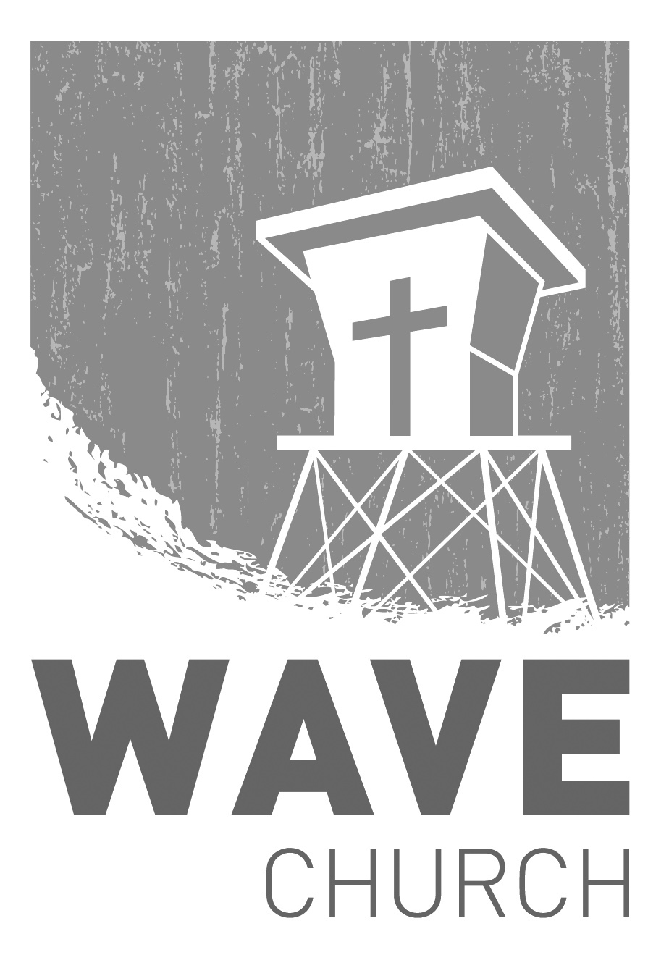
Wave Church

Welcome to

Connect | Grow | Serve

Sundays at 10 a.m.
Willow Grove Elementary
14727 Via Azul
San Diego, CA | 92127
858-859-2831
Wavechurchsd.com

