LOVE LIKE JESUS | FORGIVE
WAVE CHURCH SD | MARCH 8, 2020

HOW DO WE LOVE LIKE JESUS?

FORGIVE LIKE JESUS

Matthew 6:14-15 (ESV)
¹⁴ For if you forgive others their trespasses, your heavenly Father will also forgive you, ¹⁵ but if you do not forgive others their trespasses, neither will your Father forgive your trespasses.

Luke 23:32-43 (ESV)
³² Two others, who were criminals, were led away to be put to death with him. ³³ And when they came to the place that is called The Skull, there they crucified him, and the criminals, one on his right and one on his left. ³⁴ And Jesus said, “Father, forgive them, for they know not what they do.” And they cast lots to divide his garments. ³⁵ And the people stood by, watching, but the rulers scoffed
at him, saying, “He saved others; let him save himself, if he is the Christ of God, his Chosen One!” ³⁶ The soldiers also mocked him, coming up and offering him sour wine ³⁷ and saying, “If you are the King of the Jews, save yourself!” ³⁸ There was also an inscription over him, “This is the King of the Jews.” ³⁹ One of the criminals who were hanged railed at him, saying, “Are you not the Christ? Save yourself and us!” ⁴⁰ But the other rebuked him, saying, “Do you not fear God, since you are under the same sentence of condemnation? ⁴¹ And we indeed justly, for we are receiving the due reward of our deeds; but this man has done nothing wrong.” ⁴² And he said, “Jesus, remember me when you come into your kingdom.” ⁴³ And
he said to him, “Truly, I say to you, today you will be with me in paradise.”

HOW DO WE FORGIVE LIKE JESUS?

- PRAY FOR THOSE WHO HURT YOU

Luke 6:28-31 (NIV)
²⁷ “But I say to you who hear, Love your enemies, do good to those who hate you, ²⁸ bless those who curse you, pray for those who abuse you. ²⁹ To one who strikes you on the cheek, offer the other also, and from one who takes away your cloak do not withhold your tunic either. ³⁰ Give to everyone who begs from you, and from one who takes away your goods do not demand them back. ³¹ And as you wish that others would do to you, do so to them.
Matthew 5:43-45 (ESV)
⁴³ “You have heard that it was said, ‘You shall love your neighbor and hate your enemy.’ ⁴⁴ But I say to you, Love your enemies and pray for those who persecute you, ⁴⁵ so that you may be sons of your Father who is in heaven. For he makes his sun rise on the evil and on the good, and sends rain on the just and on the unjust.

Deuteronomy 32:35 (ESV)
³⁵ Vengeance is mine, and recompense, for the time when their foot shall slip; for the day of their calamity is at hand, and their doom comes swiftly.’

Romans 12:19-21 (ESV)
¹⁹ Beloved, never avenge yourselves, but leave it to the wrath of God, for it is written, “Vengeance is mine, I will repay, says the Lord.” ²⁰ To the contrary, “if your enemy is hungry, feed him; if he is thirsty, give him something to drink; for by so doing you will heap burning coals on his head.” ²¹ Do not be overcome by evil, but overcome evil with good.

- GIVE MERCY

MERCY | compassion or forgiveness shown toward someone whom it
is within one’s power to punish or harm.

Colossians 3:12-13 (ESV)
¹² Put on then, as God’s chosen ones, holy and beloved, compassionate hearts, kindness, humility, meekness, and patience, ¹³ bearing with one another and, if one has a complaint against another, forgiving each other; as the Lord has forgiven you, so you also must forgive.

- FORGIVE AS YOU HAVE BEEN FORGIVEN

“Bitterness is like drinking poison and hoping
the other person dies.”

– Anne Lamott

CONNECT.
.
DEFY DRIFT | defydrift.com
Often times in our relationships, we lose the art of conversation because of all the “business items” of life that take over. If you are looking for some great conversation starters for your next date night, road trip, or late evening on the couch, check out these conversation cards for couples at defydrift.com.
WAVE WEEKLY NEWSLETTER
Want to keep up with all that is going on at Wave? Simply fill out your communication card and write ‘Newsletter’ to get a weekly email update
from Wave!
GROW.
.
MARRIAGE WORKSHOP | Apr. 18th
If you are looking for the next step to take in your marriage, sign up for our one-day marriage workshop on Saturday, April 18th. We will be meeting from 10 a.m. to 3 p.m., and lunch will be served. Please see the registration link in the newsletter or on our website at wavechurchsd.com/events.
SERMON PODCASTS | wavechurchsd.com/sermons/
Want to hear a sermon again, or share it with a friend or family member? Download our sermon podcasts at wavechurchsd.com/sermons/. Available now, in addition to our podcasts, is a video of the Sunday sermon! Access it on our Website or on the Wave Church SD YouTube channel.
SERVE.
.
MEDICAL MISSION TRIP | Mar. 19th
Calling all medical professionals! Wave is taking a serve team to the Siloé
Clinic in La Misión, Mexico on Thursday, Mar. 19, 2020. If you are interested in serving in their medical clinic for the day, or would like more details, please email Keith Coffey at jkcoffey@gmail.com.
HOW CAN YOU HELP? | Serve Teams
We have many service opportunities here at Wave that are always happy to welcome more volunteers. Are you part of a serve team yet? Serving is a great way to make new connections, while making a difference in our church body. Please fill out a Communication Card with your name and an area you would be willing to serve, and a team leader will be in touch with you!

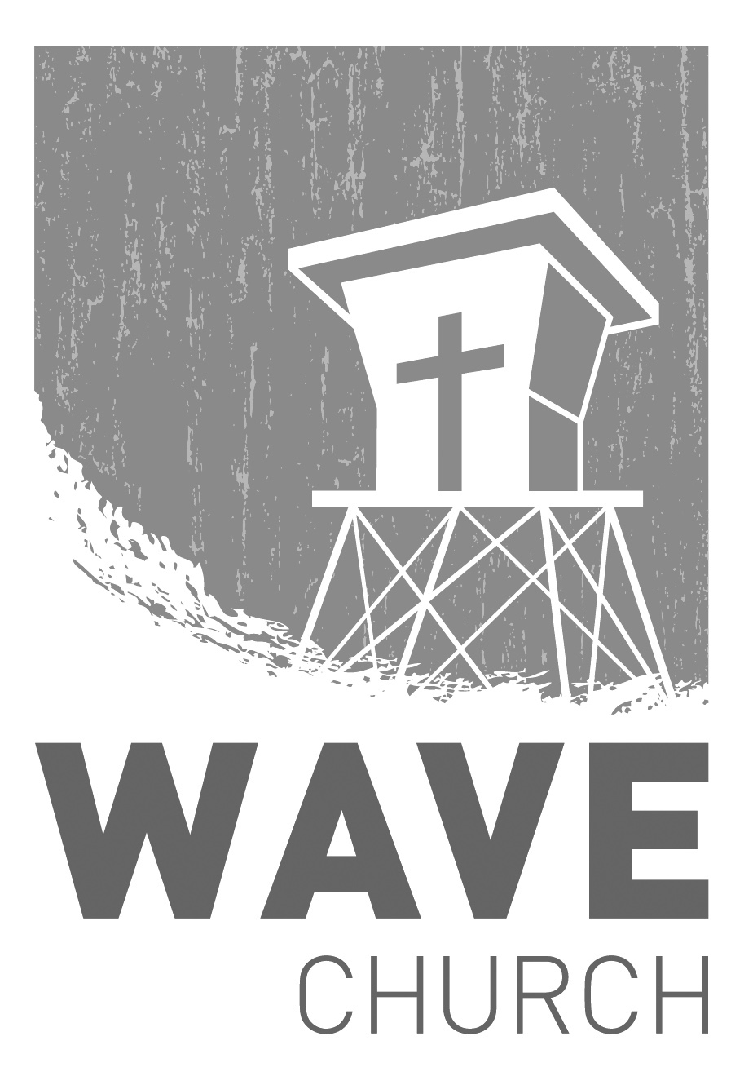
Wave Church

Welcome to

Connect | Grow | Serve

Sundays at 10 a.m.
Willow Grove Elementary
14727 Via Azul
San Diego, CA | 92127
858-859-2831
Wavechurchsd.com

