LOVE LIKE JESUS | IRRATIONAL SERVICE
WAVE CHURCH SD | MARCH 15, 2020

HOW DO WE LOVE LIKE JESUS?

IRRATIONAL ACTS OF SERVICE

John 13:1-2 (ESV)
Now before the Feast of the Passover, when Jesus knew that his hour had come to depart out of this world to the Father, having loved his own who were in the world, he loved them to the end. ² During supper, when the devil had already put it into the heart of Judas Iscariot, Simon’s son, to betray him…

Matthew 20:25-28 (ESV)
²⁵ You know that the rulers of the Gentiles lord it over them, and their great ones exercise authority over them. ²⁶ It shall not be so among you. But whoever would be great among you must be your servant, ²⁷ and whoever would be first among you must be your slave, ²⁸ even as the Son of Man came not to be served but to serve, and to give his life as a ransom for many.”

John 13:3-5 (ESV)
³ Jesus, knowing that the Father had given all things into his hands, and that he had come from God and was going back to God, ⁴ rose from supper. He laid aside his outer garments, and taking a towel, tied it around his waist. ⁵ Then he poured water into a basin and began to wash the disciples’ feet and to wipe them with the towel that was wrapped around him.

HOW DO WE LOVE THROUGH ACTS OF SERVICE?

- SEE THE NEED

- OVERCOME YOUR EXCUSES

“I would rather be a servant in Jesus’ kingdom
than the master of my own!”

- SERVING IS NOT WHAT I DO – IT IS WHO I AM

“Little things often.”

John 13:12-17 (ESV)
¹² When he had washed their feet and put on his outer garments and resumed his place, he said to them, “Do you understand what I have done to you? ¹³ You call me Teacher and Lord, and you are right, for so I am. ¹⁴ If I then, your Lord and Teacher, have washed your feet, you also ought to wash one another’s feet. ¹⁵ For I have given you an example, that you also should do just as I have done to you. ¹⁶ Truly, truly, I say to you, a servant is not greater than his master, nor is a messenger greater than the one who sent him. ¹⁷ If you know these things, blessed are you if you do them.

- NOTHING IS BELOW ME

CONNECT.
.
WAVE WEEKLY NEWSLETTER
Want to keep up with all that is going on at Wave? Simply fill out your communication card and write ‘Newsletter’ to get a weekly email update
from Wave!
LADIES’ NIGHT PAINT PARTY | Apr. 3rd
We are excited to bring you a special ladies’ night this Spring – we’re hosting a paint party! An artist from Your Creative Avenue will be guiding us step-by-step through one of two picture options. The cost is $40 per person, and no experience is necessary. Sign-up today at wavechurch.com/events or via our Newsletter link.
GROW.
.
MARRIAGE WORKSHOP | Apr. 18th
If you are looking for the next step to take in your marriage, sign up for our one-day marriage workshop on Saturday, April 18th. We will be meeting from 10 a.m. to 3 p.m., and lunch will be served. Please see the registration link in the newsletter or on our website at wavechurchsd.com/events.
SERMON PODCASTS | wavechurchsd.com/sermons/
Want to hear a sermon again, or share it with a friend or family member? Download our sermon podcasts at wavechurchsd.com/sermons/. Available now, in addition to our podcasts, is a video of the Sunday sermon! Access it on our Website or on the Wave Church SD YouTube channel.
SERVE.
.
HOW CAN YOU HELP? | Serve Teams
We have many service opportunities here at Wave that are always happy to welcome more volunteers. Are you part of a serve team yet? Serving is a great way to make new connections, while making a difference in our church body. Please fill out a Communication Card with your name and an area you would be willing to serve, and a team leader will be in touch with you!

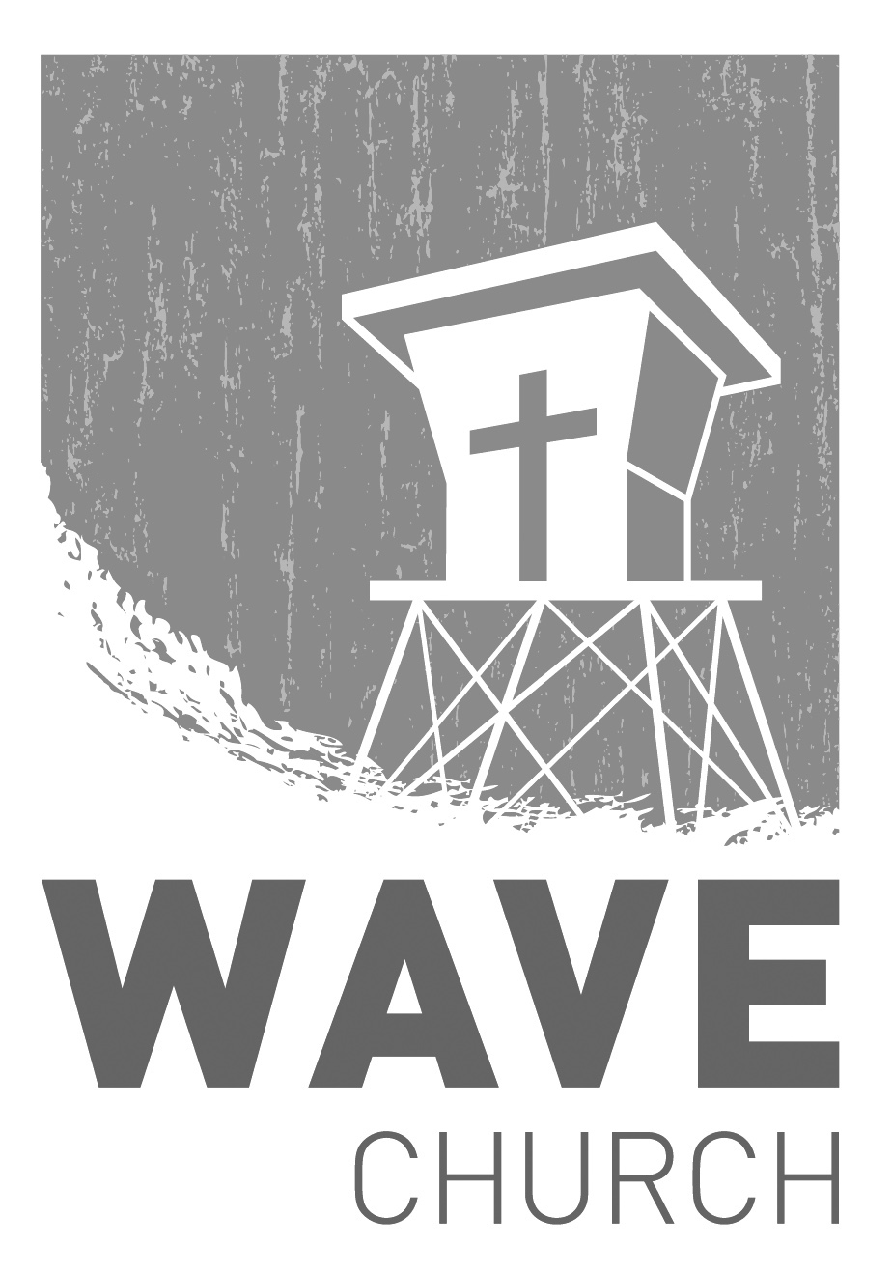
Wave Church

Welcome to

Connect | Grow | Serve

Sundays at 10 a.m.
Willow Grove Elementary
14727 Via Azul
San Diego, CA | 92127
858-859-2831
Wavechurchsd.com

