WAVE CHURCH SD | THANK GOD
GENEROSITY | NOV. 17, 2019
2 Corinthians 9:6-9 (ESV) ⁶ The point is this: whoever sows sparingly will also reap sparingly, and whoever sows bountifully will also reap bountifully. ⁷ Each one must give as he has decided in his heart, not reluctantly or under compulsion, for God loves a cheerful giver. ⁸ And God is able to make all grace abound to you, so that having all sufficiency in all things at all times, you may abound in every good work. ⁹ As it is written, “He has distributed freely, he has given to the poor; his righteousness endures forever.”

GIVING AND BEING GENEROUS ARE TWO DIFFERENT THINGS

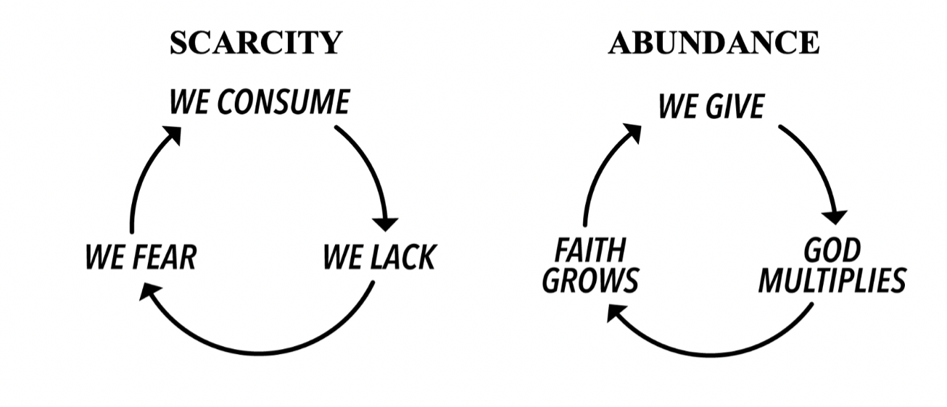
GRATITUDE TURNS WHAT IS BEFORE ME INTO ENOUGH

A HEART FULL OF GRATITUDE WILL LEAD TO
A LIFETIME OF GENEROSITY
2 Corinthians 9:10-15 (ESV) ¹⁰ For God is the one who provides seed for the farmer and then bread to eat. In the same way, he will provide and increase your resources and then produce a great harvest of generosity in you. ¹¹ Yes, you will be enriched in every way so that you can always be generous. And when we take your gifts to those who need them, they will thank God. ¹² So two good things will result from this ministry of giving—the needs of the believers in Jerusalem will be met, and they will joyfully express their thanks to God. ¹³ As a result of your ministry, they will give glory to God. For your generosity to them and to all believers will prove that you are obedient to the Good News of Christ. ¹⁴ And they will pray for you with deep affection because of the overflowing grace God has given to you. ¹⁵ Thank God for this gift too wonderful for words!
PEOPLE THANK GOD BECAUSE…

- YOU ARE GENEROUSLY SPREADING GOD’S WORD

John 1:1-5 (ESV) ¹In the beginning was the Word, and the Word was with God, and the Word was God. ² He was in the beginning with God. ³ All things were made through him, and without him was not any thing made that was made. ⁴ In him was life, and the life was the light of men. ⁵ The light shines in the darkness, and the darkness has not overcome it.

Hebrews 4:12-13 (ESV) ¹² For the word of God is living and active, sharper than any two-edged sword, piercing to the division of soul and of spirit, of joints and of marrow, and discerning the thoughts and intentions of the heart. ¹³ And no creature is hidden from his sight, but all are naked and exposed to the eyes of him to whom we must give account.

- YOU ARE GENEROUSLY BLESSING YOUR CHURCH

Ephesians 4:11-12 (ESV) ¹¹ And he gave the apostles, the prophets, the evangelists, the shepherds and teachers, ¹² to equip the saints for the work
of ministry, for building up the body of Christ…

Hebrews 10:24-25 (NLT) ²⁴ Let us think of ways to motivate one another to acts of love and good works. ²⁵ And let us not neglect our meeting together, as some people do, but encourage one another, especially now that the day of his return is drawing near.

- YOU ARE GENEROUSLY MEETING THE NEEDS OF OTHERS

Romans 12:13 (ESV) ¹³ Contribute to the needs of the saints and seek to show hospitality.

Luke 6:38 (NLT) ³⁸ Give, and you will receive. Your gift will return to you in full—pressed down, shaken together to make room for more, running over, and poured into your lap. The amount you give will determine the amount you get back.”

- YOU ARE GENEROUSLY GIVING YOUR LIFE TO CHANGE LIVES

2 Corinthians 5:20-21 (ESV) ²⁰ Therefore, we are ambassadors for Christ, God making his appeal through us. We implore you on behalf of Christ, be reconciled to God. ²¹ For our sake he made him to be sin who knew no sin, so that in him we might become the righteousness of God.
CONNECT.
Wave Church

Welcome to

Connect | Grow | Serve

Sundays at 10 a.m.
Willow Grove Elementary
14727 Via Azul
San Diego, CA | 92127
858-859-2831
Wavechurchsd.com
.
WAVE WEEKLY NEWSLETTER
Want to keep up with all that is going on at Wave? Simply fill out your communication card and write ‘Newsletter’ to get a weekly email update
from Wave!
GROW.
.
SERMON PODCASTS | wavechurchsd.com/sermons/
Want to hear a sermon again, or share it with a friend or family member? Download our sermon podcasts at wavechurchsd.com/sermons/. Available now in addition to our podcasts is a video of the Sunday sermon! Access it on our Website or on the Wave Church SD YouTube channel.
SERVE.
.
Children’s Ministry | Serve Teams
Our church is blessed with children, and our desire is to provide them with a solid, loving foundation of the Gospel – teaching them who Jesus is and why we need Him in our lives. We have exciting Bible-based curriculum to help us do this, but we need teachers! Or if you need a baby fix, please volunteer in the nursery to hold babies and love on our little ones.

- Nursery volunteers
- Kids’ Classroom volunteers

