WAVE CHURCH SD | WORSHIP SUNDAY
NOV. 24, 2019

WORSHIP

AN ACT SHOWING REVERENCE, ADORATION,
HONOR TO GOD

- WHEN WORSHIP BECOMES ROUTINE, IT HAS THE POTENTIAL TO LOSE ITS MEANING

Matthew 15:8-9 (ESV)
⁸ “ ‘This people honors me with their lips, but their heart is far from me; ⁹ in vain do they worship me, teaching as doctrines the commandments of men.’ ”

Psalm 100:1-5 (ESV) ¹ Make a joyful noise to the Lord, all the earth! ² Serve the Lord with gladness! Come into his presence with singing! ³ Know that the Lord, he is God! It is he who made us, and we are his; we are his people, and the sheep of his pasture. ⁴ Enter his gates with thanksgiving, and his courts with praise! Give thanks to him; bless his name! ⁵ For the Lord is good; his steadfast love endures forever, and his faithfulness to all generations.

- OUR ACTIONS LEAD OUR HEARTS

THREE ELEMENTS OF WORSHIP
- ACCEPT THERE IS A GOD AND HE IS FOR ME!

Hebrews 11:6 (NLT)
⁶ And it is impossible to please God without faith. Anyone who wants to come to him must believe that God exists and that he rewards those who sincerely seek him.

Romans 8:31-32 (NLT)
³¹ What shall we say about such wonderful things as these? If God is for us, who can ever be against us? ³² Since he did not spare even his own Son but gave him up for us all, won’t he also give us everything else?
- ACKNOWLEDGE WHO I AM BEFORE GOD

Psalm 46:10-11 (NLT)
¹⁰ “Be still, and know that I am God! I will be honored by every nation. I will be honored throughout the world.” ¹¹ The Lord of Heaven’s Armies is here among us; the God of Israel is our fortress.

Psalm 139:1-2 (NLT)
¹ O Lord, you have examined my heart and know everything about me. ² You know when I sit down or stand up. You know my thoughts even when I’m far away.
- ACT IN WORSHIP

Psalm 95:6-7 (NLT)
⁶ Come, let us worship and bow down. Let us kneel before the Lord our maker, ⁷ for he is our God. We are the people he watches over, the flock under his care. If only you would listen to his voice today!

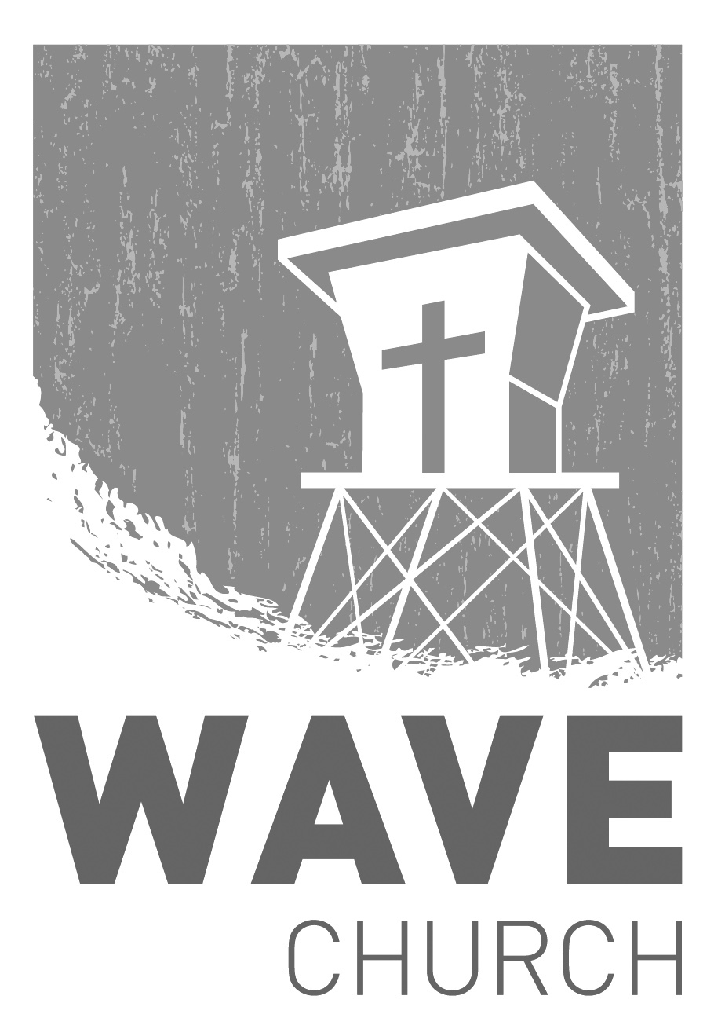
Wave Church

Welcome to

Connect | Grow | Serve

Sundays at 10 a.m.
Willow Grove Elementary
14727 Via Azul
San Diego, CA | 92127
858-859-2831
Wavechurchsd.com
CONNECT.
Wave Church

Welcome to

Connect | Grow | Serve

Sundays at 10 a.m.
Willow Grove Elementary
14727 Via Azul
San Diego, CA | 92127
858-859-2831
Wavechurchsd.com
.
LADIES ORNAMENT EXCHANGE | Dec. 6th
Come join us for a wonderful evening of fellowship, Christmas cheer, and ornament swapping -- and swiping! Please bring either an appetizer or a dessert, and a wrapped ornament for the exchange. Register today via the Newsletter or on our Website at wavechurchsd.com/events.

WAVE WEEKLY NEWSLETTER
Want to keep up with all that is going on at Wave? Simply fill out your communication card and write ‘Newsletter’ to get a weekly email update
from Wave!
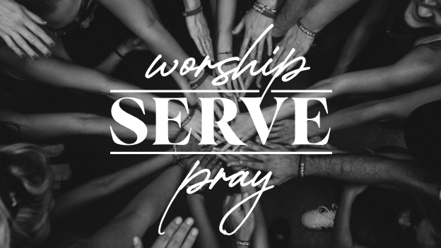
GROW.
.
SERMON PODCASTS | wavechurchsd.com/sermons/
Want to hear a sermon again, or share it with a friend or family member? Download our sermon podcasts at wavechurchsd.com/sermons/. Available now, in addition to our podcasts, is a video of the Sunday sermon! Access it on our Website or on the Wave Church SD YouTube channel.
SERVE.
.
CAROLING AT CASA ALDEA | Dec. 8th
We invite you to join us after service on Dec. 8th to spread some Christmas cheer to our neighbors at Casa Aldea Senior Center! We are excited for an opportunity to be a blessing to this community, and know that you will be blessed by this, too. Come sing some of our favorite Christmas songs and help lift the spirits of people who are in need of God’s light and love this season. We will walk over together as a group immediately following our church service.

GIFTS TO ROMANIAN ORPHANS | Dec. 15th
Every child deserves to smile at Christmas, and at Wave, we want to do our part to make that happen by sending gifts to the orphans in Romania. Gift giving is easy: simply pick up your jumbo Ziploc bag (or bags!) and a gift suggestion sheet at church, and fill that bag with goodies for a girl or boy, ages 4-18. Get your kids and family involved by shopping together, and possibly including a hand-written card or drawing. Please return your bag(s) to church by Dec. 15th.

