WAVE CHURCH SD | JONAH’S PRAYER
Jonah 2 | Oct. 13, 2019

Jonah 1:17 (ESV)
And the Lord appointed a great fish to swallow up Jonah. And Jonah was in the belly of the fish three days and three nights.

GOD’S SEVERE MERCIES PREPARE US FOR OUR PURPOSE.

GOD CARES MORE ABOUT OUR CHARACTER THAN OUR COMFORT.

EMBRACE FAILURE AS A MERCY FROM GOD.

YOU NEVER REALIZE JESUS IS ALL YOU NEED
UNTIL JESUS IS ALL YOU HAVE.

MATTHEW 10:39 (ESV)
Whoever finds his life will lose it, and whoever loses his life for my sake will find it.

THREE CRUCIAL TRUTHS

Jonah 2:1-3 (ESV)
“I called out to the Lord, out of my distress,
and he answered me;
out of the belly of Sheol I cried,
and you heard my voice.
³ For you cast me into the deep,
into the heart of the seas,
and the flood surrounded me;
all your waves and your billows
passed over me.

- THERE IS DIVINE JUSTICE THAT I DESERVE

Jonah 2:4-6 (ESV)
⁴ Then I said, ‘I am driven away
from your sight;
yet I shall again look
upon your holy temple.’
⁵ The waters closed in over me to take my life;
the deep surrounded me;
weeds were wrapped about my head
⁶ at the roots of the mountains.
I went down to the land
whose bars closed upon me forever;
yet you brought up my life from the pit,
O Lord my God.

- I CANNOT FIX MYSELF

Jonah 2:6-9 (ESV)
…yet you brought up my life from the pit,
O Lord my God.
⁷ When my life was fainting away,
I remembered the Lord,
and my prayer came to you,
into your holy temple.
⁸ Those who pay regard to vain idols
forsake their hope of steadfast love.
⁹ But I with the voice of thanksgiving
will sacrifice to you;
what I have vowed I will pay.
Salvation belongs to the Lord!”

- GOD HAS SAVED ME AT INFINITE COST TO HIMSELF

GOD’S GRACE COMPELS ME TO GO AND PROCLAIM.

Jonah 2:10 (ESV)
And the Lord spoke to the fish, and it vomited Jonah out upon the dry land.

GOD TAKES OUR GREATEST FAILURES AND TURNS THEM INTO HIS GREATEST VICTORIES.

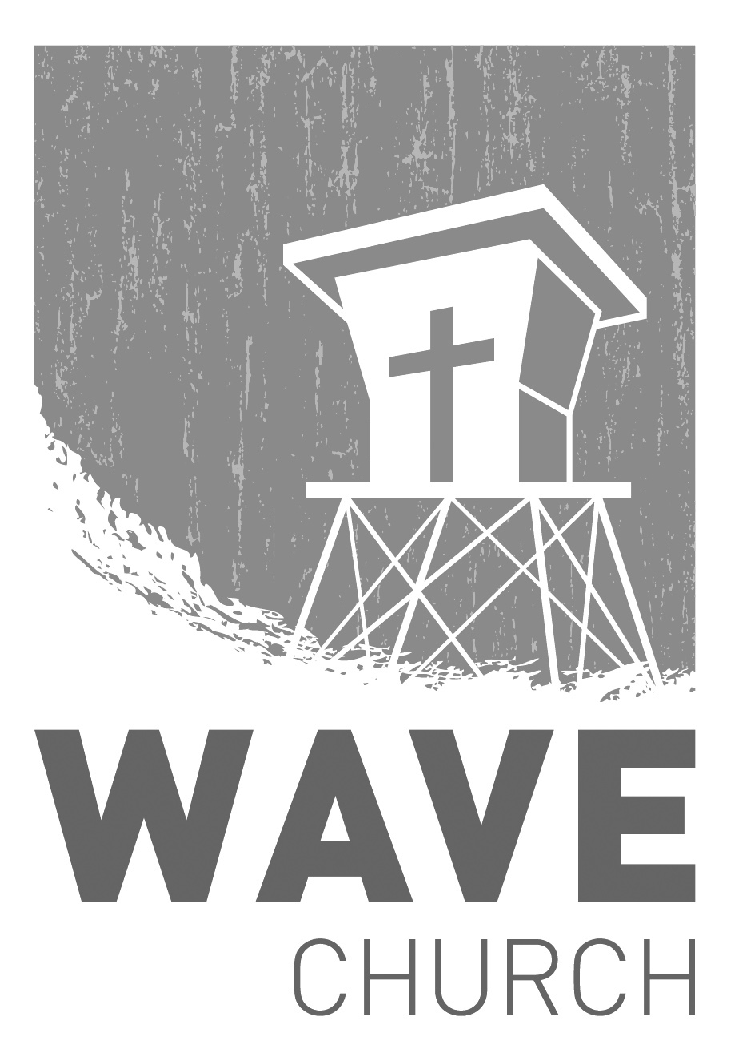
CONNECT.
Wave Church

Welcome to

Connect | Grow | Serve

Sundays at 10 a.m.
Willow Grove Elementary
14727 Via Azul
San Diego, CA | 92127
858-859-2831
Wavechurchsd.com
.
WAVE WEEKLY NEWSLETTER
Want to keep up with all that is going on at Wave? Simply fill out your communication card and write ‘Newsletter’ to get a weekly email update
from Wave!
GROW.
.
MEN’S RETREAT | Oct. 25th – 26th
Hey, Wave Men! We want you to join us for Man Camp 2019! Come and get out in God's creation, decompress and grow spiritually while camping, hiking, and laughing with your brothers in Christ. For more information and to register for the event, head to the Website at: wavechurchsd.com/events
SERVE.
.
Children’s Ministry | Serve Teams
Our church is blessed with children, and our desire is to provide them with a solid, loving foundation of the Gospel – teaching them who Jesus is and why we need Him in our lives. We have exciting Bible-based curriculum to help us do this, but we need teachers! Or if you need a baby fix, please volunteer in the nursery to hold babies and love on our little ones.

- Nursery volunteers
- Kids’ Classroom volunteers

