WAVE CHURCH SD | GOD RELENTED
Jonah 3 | Oct. 20, 2019

Jonah 3:1-2 (ESV) Then the word of the Lord came to Jonah the second time, saying, ² “Arise, go to Nineveh, that great city, and call out against it the message that I tell you.”

GOD IS A GOD OF SECOND CHANCES.

A MARK OF CHRISTIAN MATURITY IS THE DISTANCE BETWEEN
GOD’S COMMAND AND MY OBEDIENCE.

Jonah 3:3-4 (ESV) ³ So Jonah arose and went to Nineveh, according to the word of the Lord. Now Nineveh was an exceedingly great city, three days’ journey in breadth. ⁴ Jonah began to go into the city, going a day’s journey.

YOU HAVE TO GO ALL IN.

“Jonah began” | Chalal | חָלַל
- To tear away, pierce, wound, defiled, profaned, humbled;
take on a lower status.

WE MUST LET GO IN ORDER TO MOVE INTO GOD’S CALLING.

Jonah 3:4 (ESV) And he called out, “Yet forty days, and Nineveh shall be overthrown!”

THE MERCY OF GOD IS A LIMITED-TIME OFFER.

Jonah 3:5-9 (ESV) ⁵ And the people of Nineveh believed God. They called for a fast and put on sackcloth, from the greatest of them to the least of them. ⁶ The word reached the king of Nineveh, and he arose from his throne, removed his robe, covered himself with sackcloth, and sat in ashes. ⁷ And he issued a proclamation and published through Nineveh, “By the decree of the king and his nobles: Let neither man nor beast, herd nor flock, taste anything. Let them not feed or drink water, ⁸ but let man and beast be covered with sackcloth, and let them call out mightily to God. Let everyone turn from his evil way and from the violence that is in his hands. ⁹ Who knows? God may turn and relent and turn from his fierce anger, so that we may not perish.”

REPENTANCE IS ALWAYS A WORK OF GOD.

REPENTANCE IS CHANGING OUR “GOD” FIRST;
THEN OUR ACTIONS WILL FOLLOW.

Mark 1:15 (ESV) The time is fulfilled, and the kingdom of God is at hand; repent and believe in the gospel.”

Acts 3:19 (ESV) Repent, then, and turn to God, so that your sins may be wiped out, that times of refreshing may come from the Lord.

WE CAN DO THE RIGHT THINGS FOR THE WRONG REASONS.

Jonah 3:10 (ESV) ¹⁰ When God saw what they did, how they turned from their evil way, God relented of the disaster that he had said he would do to them, and he did not do it.

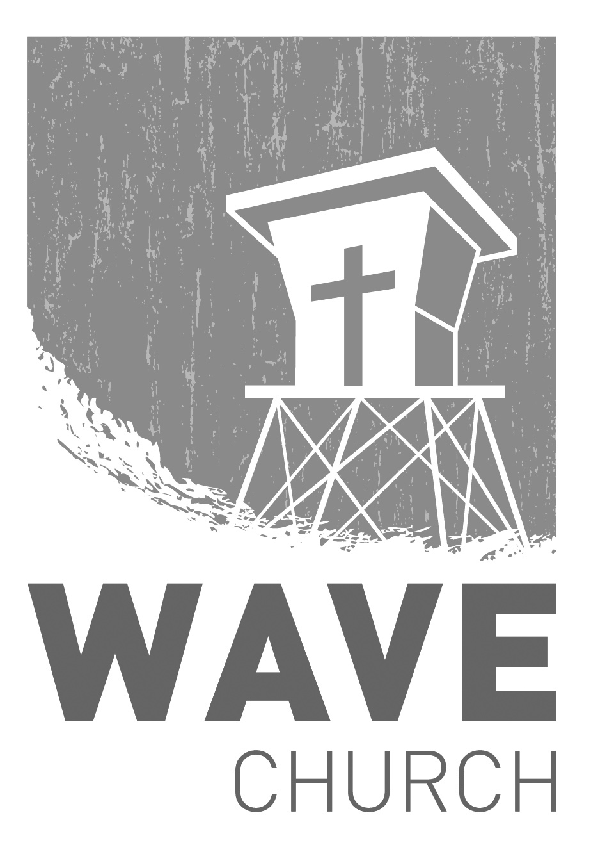
CONNECT.
Wave Church

Welcome to

Connect | Grow | Serve

Sundays at 10 a.m.
Willow Grove Elementary
14727 Via Azul
San Diego, CA | 92127
858-859-2831
Wavechurchsd.com
.
WAVE WEEKLY NEWSLETTER
Want to keep up with all that is going on at Wave? Simply fill out your communication card and write ‘Newsletter’ to get a weekly email update
from Wave!
GROW.
.
MEN’S RETREAT | Oct. 25th – Oct. 26th
Hey, Wave Men! We want you to join us for Man Camp 2019! Come and get out in God's creation, decompress and grow spiritually while camping, hiking, and laughing with your brothers in Christ. For more information and to register for the event, head to the Website at: wavechurchsd.com/events
SERMON PODCASTS | wavechurchsd.com/sermons/
Summer is in full swing – although no one has told the weather! Many of us
will be traveling and can’t make it to church, but you can still keep up with our sermons online! Want to hear a section again, or send it to a friend? Download our sermon podcasts at http://wavechurchsd.com/sermons/
SERVE.
.
Children’s Ministry | Serve Teams
Our church is blessed with children, and our desire is to provide them with a solid, loving foundation of the Gospel – teaching them who Jesus is and why we need Him in our lives. We have exciting Bible-based curriculum to help us do this, but we need teachers! Or if you need a baby fix, please volunteer in the nursery to hold babies and love on our little ones.

- Nursery volunteers
- Kids’ Classroom volunteers

