WAVE CHURCH SD | AN ANGRY PROPHET
Jonah 4 | Oct. 27, 2019

Jonah 4:1-5 (ESV) But it displeased Jonah exceedingly, and he was angry. ² And he prayed to the Lord and said, “O Lord, is not this what I said when I was yet in my country? That is why I made haste to flee to Tarshish; for I knew that you are a gracious God and merciful, slow to anger and abounding in steadfast love, and relenting from disaster. ³ Therefore now, O Lord, please take my life from me, for it is better for me to die than to live.” ⁴ And the Lord said, “Do you do well to be angry?” ⁵ Jonah went out of the city and sat to the east of the city and made a booth for himself there. He sat under it in the shade, till he should see what would become of the city.

JONAH HAS AN ANGER PROBLEM

- WITHDRAW – Jonah 1:3 (ESV) But Jonah rose to flee to Tarshish from the presence of the Lord.

- APATHY – Jonah 1:5 (ESV) Then the mariners were afraid, and each cried out to his god. And they hurled the cargo that was in the ship into the sea to lighten it for them. But Jonah had gone down into the inner part of the ship and had lain down and was fast asleep.

- SHAME – Jonah 1:12 (ESV) He said to them, “Pick me up and hurl me into the sea; then the sea will quiet down for you, for I know it is because of me that this great tempest has come upon you.”

- JUDGMENTAL – Jonah 3:4 (ESV) And he called out, “Yet forty days, and Nineveh shall be overthrown!”

ANGER WARPS OUR PERSPECTIVE

ANGER PROVES WHAT JONAH TRULY WORSHIPS

Ephesians 6:6-7 (ESV) ⁶ not by the way of eye-service, as people-pleasers, but as bondservants of Christ, doing the will of God from the heart, ⁷ rendering service with a good will as to the Lord and not to man,

JONAH DOES NOT UNDERSTAND GOSPEL FORGIVENESS

- IT IS NOT VENGEANCE

- IT IS NOT RESIGNATION

LOVE
JUSTICE
POWER

WE CANNOT TRULY FORGIVE WITHOUT A GOSPEL IDENTITY

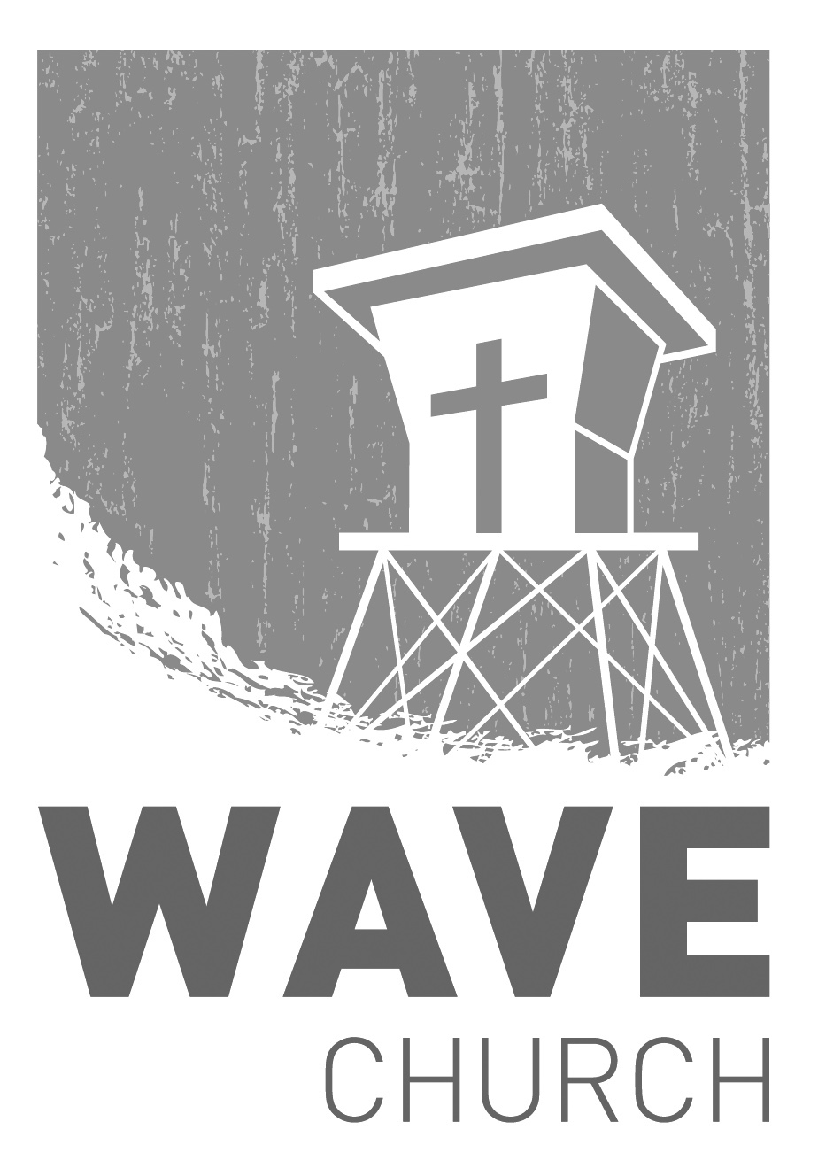
CONNECT.
Wave Church

Welcome to

Connect | Grow | Serve

Sundays at 10 a.m.
Willow Grove Elementary
14727 Via Azul
San Diego, CA | 92127
858-859-2831
Wavechurchsd.com
.
WAVE WEEKLY NEWSLETTER
Want to keep up with all that is going on at Wave? Simply fill out your communication card and write ‘Newsletter’ to get a weekly email update
from Wave!
GROW.
.
LIFE GROUP STUDY GUIDE | wavechurchsd.com/study/
Look online for our Life Group study guides. If you want to dig deeper in your understanding, and learn how to apply today’s text to your personal life, then check out this week’s study questions at http://wavechurchsd.com/study/.
SERMON PODCASTS | wavechurchsd.com/sermons/
Want to hear a sermon again, or share it with a friend or family member? Download our sermon podcasts at http://wavechurchsd.com/sermons/.
Available now in addition to our podcasts is a video of the Sunday sermon! Access it on our Website or on the Wave Church SD YouTube channel.
SERVE.
.
Children’s Ministry | Serve Teams
Our church is blessed with children, and our desire is to provide them with a solid, loving foundation of the Gospel – teaching them who Jesus is and why we need Him in our lives. We have exciting Bible-based curriculum to help us do this, but we need teachers! Or if you need a baby fix, please volunteer in the nursery to hold babies and love on our little ones.

- Nursery volunteers
- Kids’ Classroom volunteers

