WAVE CHURCH SD | Three Streams of Christian Maturity
Colossians 3:11-4:1 | Sept. 1, 2019

Colossians 3:11-12 (ESV) ¹¹ Here there is not Greek and Jew, circumcised and uncircumcised, barbarian, Scythian, slave, free; but Christ is all, and in all. ¹² Put on then, as God’s chosen ones, holy and beloved, compassionate hearts, kindness, humility, meekness, and patience…

Romans 8:31-39 (ESV) ³¹ What then shall we say to these things? If God is for us, who can be against us? ³² He who did not spare his own Son but gave him up for us all, how will he not also with him graciously give us all things? ³³ Who shall bring any charge against God’s elect? It is God who justifies. ³⁴ Who is to condemn? Christ Jesus is the one who died—more than that, who was raised—who is at the right hand of God, who indeed is interceding for us. ³⁵ Who shall separate us from the love of Christ? Shall tribulation, or distress, or persecution, or famine, or nakedness, or danger, or sword? ³⁶ As it is written, “For your sake
we are being killed all the day long; we are regarded as sheep to be slaughtered.” ³⁷ No, in all these things we are more than conquerors through him who loved us. ³⁸ For I am sure that neither death nor life, nor angels nor rulers, nor things present nor things to come, nor powers, ³⁹ nor height nor depth, nor anything
else in all creation, will be able to separate us from the love of God in Christ Jesus our Lord.
STREAM #1: JESUS LOVES ME |
GOD CALLS US TO LIVE IN HIS LOVE
Hebrews 12:1-2 (ESV) Therefore, since we are surrounded by so great a cloud of witnesses, let us also lay aside every weight, and sin which clings so closely, and let us run with endurance the race that is set before us, ² looking to Jesus, the founder and perfecter of our faith, who for the joy that was set before him endured the cross, despising the shame, and is seated at the right hand of the throne of God.

GOD’S LOVE FOR ME PRODUCES TWO THINGS:

- REPENTANCE

- GRATITUDE

STREAM #2: JESUS LOVES HIS CHURCH |
WE ARE CALLED TO LIVE IN GOSPEL COMMUNITY
Acts 2:42-47 (ESV) ⁴² And they devoted themselves to the apostles’ teaching and the fellowship, to the breaking of bread and the prayers. ⁴³ And awe came upon every soul, and many wonders and signs were being done through the apostles. ⁴⁴ And all who believed were together and had all things in common. ⁴⁵ And they were selling their possessions and belongings and distributing the proceeds to all, as any had need. ⁴⁶ And day by day, attending the temple together and breaking bread in their homes, they received their food with glad and generous hearts, ⁴⁷ praising God and having favor with all the people. And the Lord added to their number day by day those who were being saved.

Colossians 3:12-17 (ESV) ¹² Put on then, as God’s chosen ones, holy and beloved, compassionate hearts, kindness, humility, meekness, and patience, ¹³ bearing with one another and, if one has a complaint against another, forgiving each other; as the Lord has forgiven you, so you also must forgive. ¹⁴ And above all these put on love, which binds everything together in perfect harmony. ¹⁵ And let the peace of Christ rule in your hearts, to which indeed you were called in one body. And be thankful. ¹⁶ Let the word of Christ dwell in you richly, teaching and admonishing one another in all wisdom, singing psalms and hymns and spiritual songs, with thankfulness in your hearts to God. ¹⁷ And whatever you do, in word or deed, do everything in the name of the Lord Jesus, giving thanks to God the Father through him.

STREAM #3: JESUS KNOWS I WILL MESS IT UP |
WE ARE CALLED TO A LIFE OF REPENTANCE

Colossians 3:18-4:1 (ESV) ¹⁸ Wives, submit to your husbands, as is fitting in the Lord. ¹⁹ Husbands, love your wives, and do not be harsh with them. ²⁰ Children, obey your parents in everything, for this pleases the Lord. ²¹ Fathers, do not provoke your children, lest they become discouraged. ²² Bondservants, obey in everything those who are your earthly masters, not by way of eye-service, as people-pleasers, but with sincerity of heart, fearing the Lord. ²³ Whatever you do, work heartily, as for the Lord and not for men, ²⁴ knowing that from the Lord you will receive the inheritance as your reward. You are serving the Lord Christ. ²⁵ For the wrongdoer will be paid back for the wrong he has done, and there is no partiality. ¹ Masters, treat your bondservants justly and fairly, knowing that you also have a Master in heaven.

Matthew 3:8 (ESV) Bear fruit in keeping with repentance.

1 John 1:8-10 (ESV) ⁸ If we say we have no sin, we deceive ourselves, and the truth is not in us. ⁹ If we confess our sins, he is faithful and just to forgive us our sins and to cleanse us from all unrighteousness. ¹⁰ If we say we have not sinned, we make him a liar, and his word is not in us.
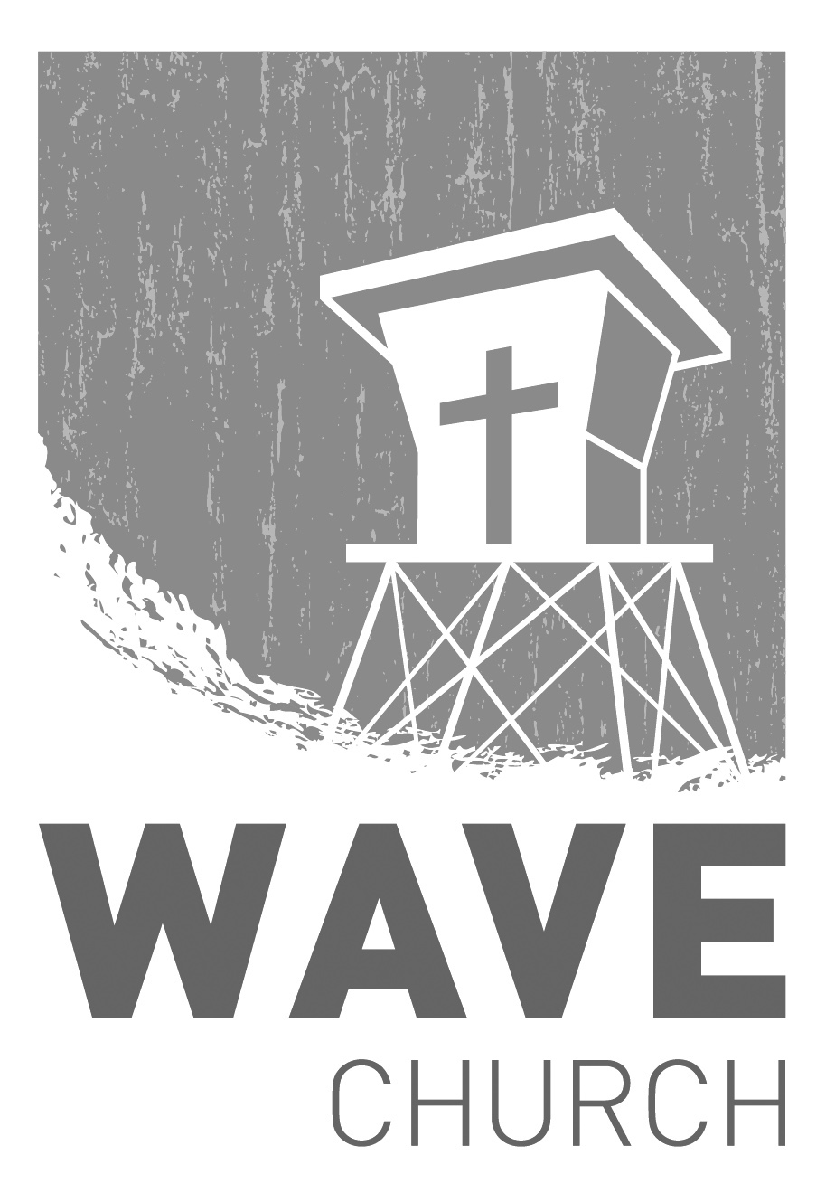
CONNECT.
Connect | Grow | Serve

Wave Church

Welcome to

Sundays at 10 a.m.
Willow Grove Elementary
14727 Via Azul
San Diego, CA | 92127
858-859-2831
Wavechurchsd.com
.
FALL KICKOFF + 8th ANNIVERSARY! | Sept. 8th
It’s time for all things Fall, and we are kicking off the school year and celebrating Wave’s 8th Anniversary next Sunday! Please join us for street tacos, family games, and great fellowship right after church. It will be a fun party you don’t want to miss!
WAVE WEEKLY NEWSLETTER
Want to keep up with all that is going on at Wave? Simply fill out your communication card and write ‘Newsletter’ to get a weekly email update
from Wave!
GROW.
.
LIFE GROUPS | Sept. 8th
The new school year is upon us, and our next season of Life Groups is starting in just a couple of weeks! If you are new or have not joined a Life Group, please fill out a Life Group Info Card with your availability, and a group leader will be in touch with you. For those already in Life Groups, please connect with your leaders for current meeting day and time.

SERMON PODCASTS | wavechurchsd.com/sermons/
Summer is in full swing – although no one has told the weather! Many of us
will be traveling and can’t make it to church, but you can still keep up with our sermons online! Want to hear a section again, or send it to a friend? Download our sermon podcasts at http://wavechurchsd.com/sermons/
SERVE.
.
Children’s Ministry | Serve Teams
Our church is blessed with children, and our desire is to provide them with a solid, loving foundation of the Gospel – teaching them who Jesus is and why we need Him in our lives. We have exciting Bible-based curriculum to help us do this, but we need teachers! Or if you need a baby fix, please volunteer in the nursery to hold babies and love on our little ones.

- Nursery volunteers
- Kids’ Classroom volunteers

