WAVE CHURCH SD | GOD-SIZED STORMS
Jonah 1:4-5 | Sept. 15, 2019

Jonah 1:1-3 (ESV) Now the word of the Lord came to Jonah the son of Amittai, saying, ² “Arise, go to Nineveh, that great city, and call out against it, for their evil has come up before me.” ³ But Jonah rose to flee to Tarshish from the presence of the Lord. He went down to Joppa and found a ship going to Tarshish. So he paid the fare and went down into it, to go with them to Tarshish, away from the presence of the Lord.

BIG IDEA: GOD IS MERCIFUL AND JUST

Jonah 1:4 (ESV) But the Lord hurled a great wind upon the sea, and there was
a mighty tempest on the sea, so that the ship threatened to break up.

- GOD USES STORMS IN OUR LIVES TO GRAB OUR ATTENTION

Romans 8:28 (ESV) And we know that in all things God works for the good of those who love him, who have been called according to his purpose.

- GOD-SIZED STORMS LEAD TO GOD-SIZED CALLINGS

TWO TYPES OF STORMS WE FACE

STORMS ATTACHED TO SIN

- EVERY SIN HAS A STORM OF CONSEQUENCES ATTACHED TO IT

Romans 1:21-25 (ESV) ²¹ For although they knew God, they did not honor him as God or give thanks to him, but they became futile in their thinking, and their foolish hearts were darkened. ²² Claiming to be wise, they became fools, ²³ and exchanged the glory of the immortal God for images resembling mortal man and birds and animals and creeping things. ²⁴ Therefore God gave them up in the lusts of their hearts to impurity, to the dishonoring of their bodies among themselves, ²⁵ because they exchanged the truth about God for a lie and worshiped and served the creature rather than the Creator, who is blessed forever! Amen.
Jonah 1:5 (ESV) ⁵ Then the mariners were afraid, and each cried out to his god. And they hurled the cargo that was in the ship into the sea to lighten it for them. But Jonah had gone down into the inner part of the ship and had lain down and was fast asleep...

- OFTEN, OTHERS CAN SEE THE STORM COMING BEFORE WE CAN

- STORMS ARE OFTEN GOD’S GRACIOUS MEANS TO DRAW US BACK

STORMS ATTACHED TO SINNERS

- THE BIBLE DOES NOT SAY THAT EVERY DIFFICULTY IS THE RESULT OF SIN – BUT IT DOES TEACH THAT, FOR CHRISTIANS, EVERY DIFFICULTY CAN HELP REDUCE THE POWER OF SIN OVER OUR HEARTS.

James 1:2-4 (NLT) ² Dear brothers and sisters, when troubles of any kind come your way, consider it an opportunity for great joy. ³ For you know that when your faith is tested, your endurance has a chance to grow. ⁴ So let it grow, for when your endurance is fully developed, you will be perfect and complete, needing nothing.

- WITHOUT THE STORMS OF LIFE, WE WOULD NOT HAVE FAITH THAT HAS BEEN PROVEN FAITHFUL

- GOD DOES NOT ALLOW STORMS TO DESTROY US, BUT TO SHOW US WHAT HE IS CAPABLE OF DOING

- THERE IS MERCY DEEP INSIDE OUR STORMS

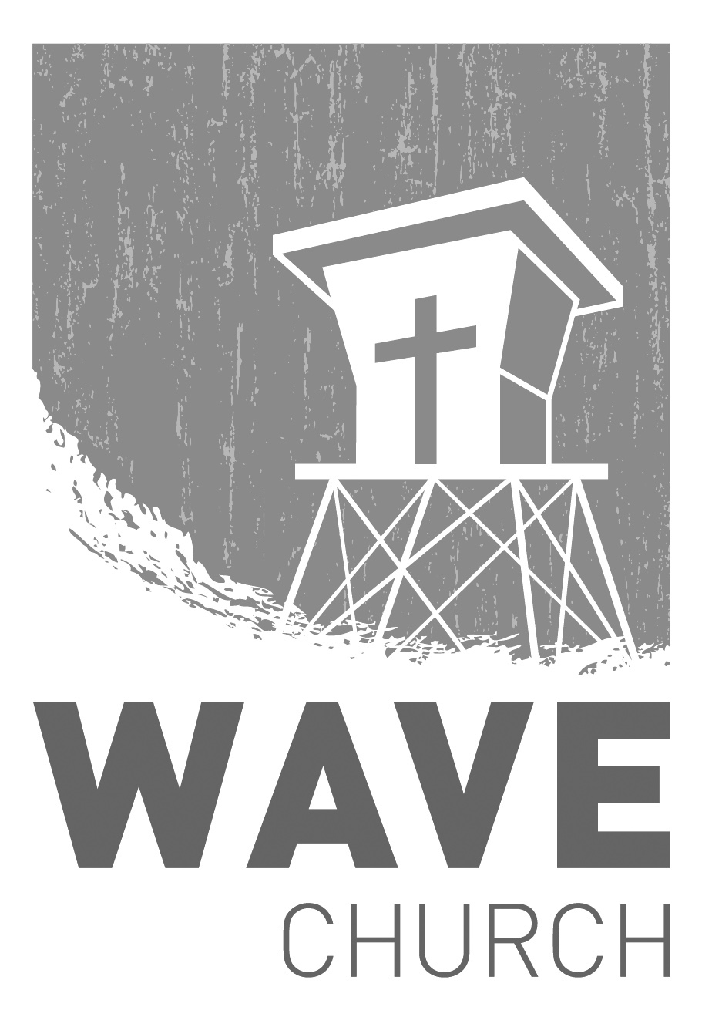
CONNECT.
Wave Church

Welcome to

Connect | Grow | Serve

Sundays at 10 a.m.
Willow Grove Elementary
14727 Via Azul
San Diego, CA | 92127
858-859-2831
Wavechurchsd.com
.
WAVE WEEKLY NEWSLETTER
Want to keep up with all that is going on at Wave? Simply fill out your communication card and write ‘Newsletter’ to get a weekly email update
from Wave!
GROW.
.
LIFE GROUPS | Sept. 8th – Nov. 22nd
Our fall season of Life Groups started last week, and there is still time to join! If you are new or have not joined a Life Group, please fill out a Life Group Info Card with your availability, and a group leader will be in touch with you.

WOMEN’S RETREAT | Sept. 28th
Ladies, we invite you to join us for a powerful, one-day retreat on how to Run the Race of life – as Christians, as a spouse, as parents, as a woman – with Perseverance. God is our ultimate life coach, supporting, encouraging, and strengthening us every step of the way. Join us as we come together to support, encourage, and uplift one another. Sign-up via the Wave Newsletter, or on the Website at www.wavechurchsd.com/events.
SERMON PODCASTS | wavechurchsd.com/sermons/
Summer is in full swing – although no one has told the weather! Many of us
will be traveling and can’t make it to church, but you can still keep up with our sermons online! Want to hear a section again, or send it to a friend? Download our sermon podcasts at http://wavechurchsd.com/sermons/
SERVE.
.
Children’s Ministry | Serve Teams
Our church is blessed with children, and our desire is to provide them with a solid, loving foundation of the Gospel – teaching them who Jesus is and why we need Him in our lives. We have exciting Bible-based curriculum to help us do this, but we need teachers! Or if you need a baby fix, please volunteer in the nursery to hold babies and love on our little ones.

- Nursery volunteers
- Kids’ Classroom volunteers

