WAVE CHURCH SD | WHO ARE YOU?
Jonah 1:7-10 | Sept. 29, 2019

Jonah 1:1-6 (ESV) Now the word of the Lord came to Jonah the son of Amittai, saying, ² “Arise, go to Nineveh, that great city, and call out against it, for their evil has come up before me.” ³ But Jonah rose to flee to Tarshish from the presence of the Lord. He went down to Joppa and found a ship going to Tarshish. So he paid the fare and went down into it, to go with them to Tarshish, away from the presence of the Lord. ⁴ But the Lord hurled a great wind upon the sea, and there was a mighty tempest on the sea, so that the ship threatened to break up. ⁵ Then the mariners were afraid, and each cried out to his god. And they hurled the cargo that was in the ship into the sea to lighten it for them. But Jonah had gone down into the inner part of the ship and had lain down and was fast asleep. ⁶ So the captain came and said to him, “What do you mean, you sleeper? Arise, call out to your god! Perhaps the god will give a thought to us, that we may not perish.”

“Genuine self-knowledge begins by looking at God and noticing
how God is looking at us.” ― David G. Benner

KNOWING WHO YOU ARE IS THE SECRET TO A
JOY-FILLED JOURNEY.

Jonah 1:7-8 (ESV) ⁷ And they said to one another, “Come, let us cast lots, that we may know on whose account this evil has come upon us.” So they cast lots, and the lot fell on Jonah. ⁸ Then they said to him, “Tell us on whose account this evil has come upon us. What is your occupation? And where do you come from? What is your country? And of what people are you?”

THREE IDENTITY-REVEALING QUESTIONS:

- WHAT IS YOUR PURPOSE? | Isaiah 43:7

  - TO GLORIFY GOD AND ENJOY HIM FOREVER

- WHAT IS YOUR PLACE? | Matt. 4:17, John 17:15-16, Eph. 3:20-21

- THE KINGDOM OF HEAVEN

- WHO ARE YOUR PEOPLE? | Eph. 2:19-22

- THE CHURCH IS MY FAMILY
WHO YOU ARE IS WHO YOU WORSHIP

Jonah 1:9-10 (ESV) ⁹ And he said to them, “I am a Hebrew, and I fear the Lord, the God of heaven, who made the sea and the dry land.” ¹⁰ Then the men were exceedingly afraid and said to him, “What is this that you have done!” For the men knew that he was fleeing from the presence of the Lord, because he had told them.

WHEN JESUS’ LOVE FOR ME BECOMES MY PRIMARY IDENTITY,
JOY AND LOYALTY WILL FOLLOW.

“Shallow Christian identities explain why professing Christians can be racists and greedy materialists, addicted to beauty and pleasure, or filled with anxiety and prone to overwork. All this comes because it is not Christ’s love but the world’s power, approval, comfort, and control that are the real roots of our self-identity.” – Tim Keller, The Prodigal Prophet

A SHALLOW IDENTITY PREVENTS ME FROM KNOWING MYSELF AND OTHERS AS THEY ARE.

- SHALLOW IDENTITY CAUSES ME TO BE BLIND TO MY FLAWS

- SHALLOW IDENTITY CAUSES ME TO BE HOSTILE TO THOSE WHO ARE DIFFERENT

John 21:15-19 (ESV) ¹⁵ When they had finished breakfast, Jesus said to Simon Peter, “Simon, son of John, do you love me more than these?” He said to him, “Yes, Lord; you know that I love you.” He said to him, “Feed my lambs.” ¹⁶ He said to him a second time, “Simon, son of John, do you love me?” He said to him, “Yes, Lord; you know that I love you.” He said to him, “Tend my sheep.” ¹⁷ He said to him the third time, “Simon, son of John, do you love me?” Peter was grieved because he said to him the third time, “Do you love me?” and he said to him, “Lord, you know everything; you know that I love you.” Jesus said to him, “Feed my sheep. ¹⁸ Truly, truly, I say to you, when you were young, you used to dress yourself and walk wherever you wanted, but when you are old, you will stretch out your hands, and another will dress you and carry you where you do not want to go.” ¹⁹ (This he said to show by what kind of death he was to glorify God.) And after saying this he said to him, “Follow me.”

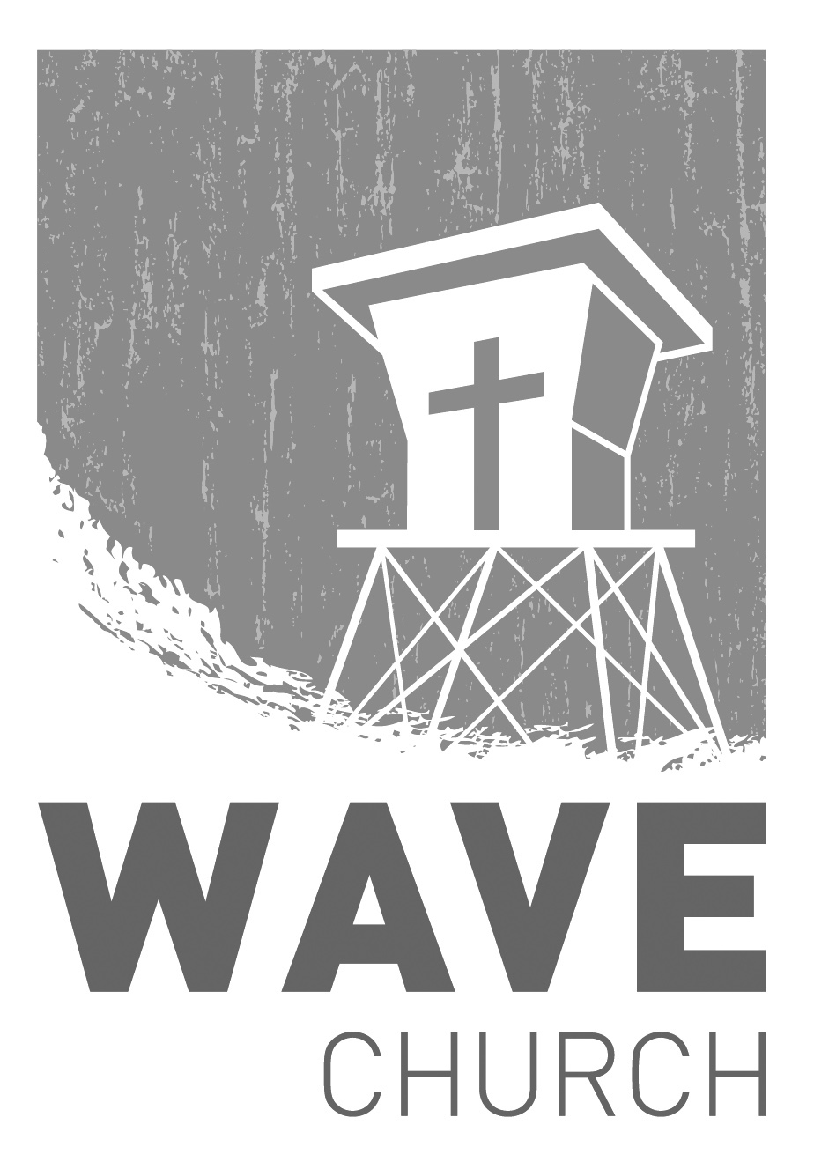
CONNECT.
Wave Church

Welcome to

Connect | Grow | Serve

Sundays at 10 a.m.
Willow Grove Elementary
14727 Via Azul
San Diego, CA | 92127
858-859-2831
Wavechurchsd.com
.
STARTING POINT | Oct. 6th
Our next Starting Point lunch is on Oct. 6th, right after church. If you would like to learn more about Wave, meet our pastors, staff, and other newcomers, then join us for a family meal, and hear about the story and heart of our church.
WAVE WEEKLY NEWSLETTER
Want to keep up with all that is going on at Wave? Simply fill out your communication card and write ‘Newsletter’ to get a weekly email update
from Wave!
GROW.
.
MEN’S RETREAT | Oct. 25th – Oct. 26th
Hey, Wave Men! We would love to invite you to join us for Man Camp 2019! Come and get out in God's creation, decompress and grow spiritually while camping, hiking, and laughing with your brothers in Christ. For more information and to register for the event, head to the Website at: wavechurchsd.com/events
SERMON PODCASTS | wavechurchsd.com/sermons/
Summer is in full swing – although no one has told the weather! Many of us
will be traveling and can’t make it to church, but you can still keep up with our sermons online! Want to hear a section again, or send it to a friend? Download our sermon podcasts at http://wavechurchsd.com/sermons/
SERVE.
.
Children’s Ministry | Serve Teams
Our church is blessed with children, and our desire is to provide them with a solid, loving foundation of the Gospel – teaching them who Jesus is and why we need Him in our lives. We have exciting Bible-based curriculum to help us do this, but we need teachers! Or if you need a baby fix, please volunteer in the nursery to hold babies and love on our little ones.

- Nursery volunteers
- Kids’ Classroom volunteers

